**UNIT 3**

**Syntactic Pattern Recognition**

Syntactic pattern recognition is an approach to pattern recognition that represents patterns through formal grammar rules. It is especially useful for recognizing patterns with inherent structural relationships, such as sequences or hierarchical data.

### ****Overview****

* Syntactic pattern recognition involves the use of grammar and language rules to describe patterns and their structural relationships.
* Patterns are treated as compositions of simpler sub patterns, which can be systematically described using grammar rules.
* Applications are common in fields such as computational linguistics, computer vision, bioinformatics, and robotics.

### ****Qualifying Structure in Pattern Description and Recognition****

The qualifying structure in pattern description and recognition refers to the specific rules and criteria used to define and identify patterns within data. It also refers to the organized and systematic representation of patterns based on their structural or relational properties. This approach aims to model patterns by defining their components, relationships, and rules for combining them into valid structures. It forms the basis of syntactic pattern recognition.

#### **1. Primitives (Basic Elements)**

Primitives are the smallest, indivisible components of a pattern.

* **Definition**: Fundamental units that make up a pattern.
* **Examples**: Points, lines, curves, characters, or symbols.
* **Significance**: Serve as the building blocks for constructing complex patterns.

#### **2. Relationships between Primitives**

Defines how primitives are related to each other spatially, temporally, or logically.

* **Types**:
  + **Spatial Relationships**: Arrangement in 2D or 3D space (e.g., proximity, alignment).
  + **Temporal Relationships**: Sequence of events or actions (e.g., order in speech recognition).
  + **Logical Relationships**: Constraints or dependencies between components.
* **Example**: In a face pattern, the eyes are positioned symmetrically around the nose.

#### **3. Grammatical Rules**

* **Description**: Patterns are defined using a set of grammatical rules that specify how elements can be combined. These rules create a formal language for describing patterns, similar to the grammar of natural languages.
* **Example**: In programming languages, the rules for syntax (e.g., how variables, operators, and functions can be combined) are crucial for the correct interpretation of code. For instance, in Python, the grammatical rule for defining a function is:
* def function_name(parameters):

# function body

#### **4. Hierarchical Structures**

* **Description**: Patterns can be organized hierarchically, where complex patterns consist of simpler sub-patterns. This allows for recognizing patterns at different levels of abstraction.
* **Example**: In image processing, a face can be considered a complex pattern that consists of simpler sub-patterns, such as eyes, nose, and mouth. Each of these sub-patterns can be recognized separately, contributing to the overall recognition of the face.

#### **5. Attributes and Features**

* **Description**: Qualifying structures include attributes or features that describe specific characteristics of the patterns. These can be quantitative (size, color) or qualitative (shape, orientation).
* **Example**: In image recognition, features such as color histograms, edges, and corners are used to distinguish between different objects. For instance, identifying a red apple versus a green apple based on their color attributes.

#### **6. Contextual Rules**

* **Description**: Contextual rules help qualify patterns based on their environment or context. This includes spatial relationships, temporal sequences, or the presence of other patterns.
* **Example**: In video analysis, a contextual rule might state that a person running should be followed by a person walking, indicating a specific sequence of actions. This context is crucial for understanding behaviors in the video.

#### **7. Formal Descriptions**

* **Description**: Patterns can be described using formal languages such as regular expressions, context-free grammars, or finite state machines. These descriptions provide a precise way to define the patterns.
* **Example**: A regular expression can describe a simple pattern for validating email addresses. For example, the regex:

^[a-zA-Z0-9._%+-][+@[a-zA-Z0-9.-]+\.[a-zA-Z]{2,}$](mailto:+@[a-zA-Z0-9.-]+\.%5ba-zA-Z%5d%7b2,%7d$) specifies the structure of valid email addresses.

#### **8. Thresholds and Constraints**

* **Description**: Qualifying structures may involve thresholds or constraints that determine when a structure is recognized as a valid pattern. This includes minimum sizes, shape ratios, or specific attribute values.
* **Example**: In anomaly detection, a threshold might be set for the number of failed login attempts. If the number exceeds a specific limit (e.g., 5 attempts), it is recognized as a potential security threat.

**Grammar-Based Approach and Applications**

The Grammar-Based Approach in syntactic pattern recognition leverages formal grammar rules to identify and classify patterns within data, particularly in language processing and other domains where structured patterns are critical. Here's an overview of the approach and its applications:

**Grammar-Based Approach**

1. **Concept**:
   * A grammar defines a set of rules or patterns for generating strings in a language. In syntactic pattern recognition, this means creating a formal representation of patterns that can be recognized or generated by a system.
2. **Types of Grammars**:
   * **Context-Free Grammars (CFGs)**: Used widely in computational linguistics, where the syntax of a language is defined by rules that describe how symbols can be replaced or combined.
   * **Context-Sensitive Grammars (CSGs)**: More complex and can capture patterns that CFGs cannot. They are used in more advanced applications where context plays a significant role.
   * **Regular Grammars**: A subset of CFGs, used for simpler pattern matching and recognition tasks.
3. **Components**:
   * **Terminals**: Basic symbols from which strings are formed.
   * **Non-terminals**: Symbols that can be replaced by combinations of terminals and other non-terminals.
   * **Production Rules**: Define how non-terminals can be replaced with other non-terminals or terminals.
   * **Start Symbol**: The initial non-terminal from which production begins.
4. **Process**:
   * **Pattern Description**: The process of defining new primitives and constraints for pattern recognition.
   * **Generation**: Creating strings that match the grammar rules, useful for testing or generating samples.
   * **Parsing**: The process of analysing a string based on grammar rules to determine if it fits the defined patterns.
   * **Recognition and Classification**: Based on the parsed data classify patterns.

**Applications**

1. **Natural Language Processing (NLP)**:
   * **Syntax Analysis**: Parsing sentences to understand grammatical structure and meaning.
   * **Machine Translation**: Translating text from one language to another by mapping grammatical structures between languages.
   * **Speech Recognition**: Converting spoken language into written text by recognizing syntactic patterns.

1. **Programming Languages**:
   * **Compilers**: Using grammars to parse and translate code written in programming languages into machine code or intermediate representations.
   * **Syntax Checking**: Ensuring that code adheres to grammatical rules of the programming language.
2. **Bioinformatics**:
   * **Gene Sequencing**: Recognizing patterns in genetic sequences to identify genes and other functional elements.
   * **Protein Structure Prediction**: Analyzing amino acid sequences based on known structural patterns.
3. **Information Retrieval**:
   * **Text Classification**: Categorizing documents based on their syntactic structure and content.
   * **Pattern Matching**: Identifying and extracting relevant information from large text corpora.
4. **Speech Recognition** :
   * **Pattern Recognition**: Enabling the Recognition of structure phrases and commands in Speech Processing.
5. **Image Recognition**:
   * **Pattern Recognition**: SYPR Helps to identify shapes and objects in image based on defined pattern e.g. Facial Recognition
6. **Artificial Intelligence**:
   * **Pattern Recognition**: Recognizing complex patterns in data, such as visual patterns in images or structured data in various formats.
   * **Knowledge Representation**: Using grammatical structures to represent and reason about knowledge in AI systems.
7. **Robotics Vision and Path Planning**:
   * **Pattern Recognition**: Robot uses SYPR to interpret environmental patterns navigate based on recognized ladmarks.

**Advantages**

* **Structured Representation**: Provides a clear and formal way to describe patterns.
* **Flexibility**: Can be adapted to various domains by modifying grammar rules.
* **Precision**: Allows for accurate recognition and generation of patterns.

**Elements of Formal Grammars, Examples of String Generation as Pattern Description:**

**Elements of Formal Grammars-**

1. **Terminals:**
   * Definition: Basic symbols from which strings are built. These are the actual characters or symbols in the strings.
   * Example: In a simple grammar for arithmetic, terminals might be numbers (1, 2, 3) and operators (+, *).
2. **Non-terminals:**
   * Definition: Symbols that can be replaced with other symbols (terminals or non-terminals) according to production rules.
   * Example: In an arithmetic grammar, non-terminals could be Expr (expression) and Term.
3. **Production Rules:**
   * Definition: Rules that define how non-terminals can be replaced with combinations of terminals and other non-terminals.
   * Example:
     + Expr can be replaced with Expr + Term or Term.
     + Term can be replaced with number or number * Term.
4. **Start Symbol:**
   * Definition: The initial non-terminal from which the generation of strings begins.
   * Example: In our arithmetic grammar, the start symbol might be Expr.

**Example of String Generation**

* Grammar:
  + Terminals: dog, barks, loudly
  + Non-terminals: Sentence, Noun Phrase, Verb Phrase
  + Production Rules:
    - Sentence -> Noun Phrase Verb Phrase
    - Noun Phrase -> dog
    - Verb Phrase -> barks | barks loudly
  + Start Symbol: Sentence

**Goal: Generate a sentence from the start symbol Sentence.**

**Steps:**

1. Start with Sentence:
   * Apply the rule Sentence -> Noun Phrase Verb Phrase.
2. For Noun Phrase:
   * Apply the rule Noun Phrase -> dog.
3. For Verb Phrase:
   * Apply the rule Verb Phrase -> barks loudly.

**Combining these results:**

* The Sentence becomes dog barks loudly.

**PARSING**

Parsing is the process of analyzing a sequence of symbols (typically words or tokens) in order to determine their syntactic structure based on a formal grammar. The goal is to derive a syntactic tree (or parse tree) that represents how the input string adheres to grammatical rules.

#### Key Concepts in Parsing:

* **Parse Tree (Syntax Tree):** A hierarchical tree-like structure that represents the syntactic structure of the input based on grammar rules.
* **Derivation:** The process of starting from the start symbol of the grammar and applying production rules to generate a string or a structure.

#### Types of Parsing:

* **Top-Down Parsing:** This type of parser begins with the start symbol of the grammar and attempts to match the input string against possible derivations. The goal is to break down the input into smaller syntactic components.
  + **Example:** A **recursive descent parser** is a common example of top-down parsing.
* **Bottom-Up Parsing:** This method starts from the input symbols (tokens) and attempts to build up the syntactic structure by applying grammar rules in reverse. The process continues until the start symbol is reached.
  + **Example:** An **LR parser** (Left-to-right)

How Does Parsing Work?

1. Identify the Start: Begin with the entire string and use rules to break it down into smaller parts.

2. Apply Rules: Use predefined rules (grammar) to determine how parts of the string relate to each other.

3. Build Structure: Construct a structured representation (like a tree) that shows how the parts fit tog/ether according to the rules.

You can visualize parsing with a simple tree diagram:

Sentence

/ \

NounPhrase VerbPhrase

/ \

The cat sleeps

• Parsing helps break down and understand a string based on grammatical rules.

• Example Sentence: The cat sleeps.

• Grammar Rules: Define how to structure the sentence.

• Process: Divide the sentence according to the rules and build a structure.

**Parsing technique**

### 1. ****CYK Parsing Algorithm****

The **CYK (Cocke-Younger-Kasami)** algorithm is a dynamic programming algorithm for parsing context-free grammars (CFG) in **Chomsky Normal Form (CNF)**. It is a bottom-up parsing method, which constructs a parse tree by combining smaller parts of the input step-by-step, starting from individual symbols.

#### **Steps in the CYK Algorithm:**

1. **Input**: The input string needs to be represented as a sequence of tokens (e.g., words in a sentence). The grammar must be in **Chomsky Normal Form (CNF)**, which means all production rules must be of the form:
   * A → BC (where A, B, C are non-terminal symbols), or
   * A → a (where A is a non-terminal and a is a terminal symbol).
2. **Initialize the Table**: Create a table (usually a 2D matrix) where each entry P[i][j] represents the set of non-terminal symbols that can generate the substring of the input from position i to position j.
3. **Fill the Table**:
   * **Base Case**: For each terminal symbol (word) in the input string, set P[i][i] to the set of non-terminals that can derive that terminal symbol. For example, if the terminal at position i is "the", and S → the is a rule in the grammar, then P[i][i] = {S}.
   * **Recursive Step**: For substrings of length greater than 1, the table is filled using a dynamic programming approach:
     + For each substring from i to j (with length greater than 1), check all possible ways to split the substring into two smaller parts (k from i to j-1). For each pair of non-terminals in P[i][k] and P[k+1][j], if there is a production rule that combines these non-terminals, then add the corresponding non-terminal to P[i][j].
4. **Check for the Start Symbol**: After filling the table, check if the start symbol of the grammar (e.g., S) is in P[0][n-1], where n is the length of the input string. If it is, the string can be derived from the grammar, and the input is syntactically valid.

### Applications of the CYK Algorithm:

1. Context-Free Grammar Parsing
2. Syntax Analysis in Compilers
3. Handling Ambiguity in NLP
4. Speech Recognition
5. Machine Translation
6. Bioinformatics (RNA Secondary Structure Prediction)
7. Formal Language Recognition
8. Parsing in Formal Systems

**Simple Example**

Let's use a simple grammar and string to illustrate the CYK algorithm.

**Grammar Rules**:

1. S -> AB
2. A -> a
3. B -> b

**String to Parse**: ab

**Steps to Apply the CYK Algorithm**:

1. **Set Up the Table**:
   * Create a table with dimensions based on the length of the string. For the string ab, we need a 2x2 table.

|   | 1 | 2 |

|---|---|---|

| 1 |   |   |

| 2 |   |   |

**Fill the Table for Single Characters**:

* For each character in the string, fill in which non-terminal can generate it:
  + a can be generated by A.
  + b can be generated by B.

Table after filling single characters:

**Fill the Table for Longer Substrings**:

* Now, consider substrings of length 2 (the whole string ab):
  + Check all possible splits of ab:
    - Split ab into a and b.
    - a (which can be generated by A) and b (which can be generated by B) can be combined using the rule S -> AB.
  + So, S can generate ab.

Final Table:

|   | 1 | 2 |

|---|---|---|

| 1 | A | S |

| 2 | B |   |

1. **Check the Start Symbol**:
   * Look at the top-right cell (which represents the whole string ab).
   * If it contains the start symbol S, then the string can be generated by the grammar.

In this example, the top-right cell has S, meaning that the string ab can indeed be generated by the grammar.

### 2. ****ATN (Augmented Transition Network) in Parsing****

An **Augmented Transition Network (ATN)** is a powerful and flexible parsing method primarily used in natural language processing. It extends the capabilities of traditional finite-state machines and context-free grammars to handle complex grammatical constructs. ATNs are widely used for syntactic analysis due to their ability to incorporate recursion, rules, and stack mechanisms, enabling more sophisticated sentence parsing.

### Key Concepts of ATNs

**States**

* **Definition**: States are points within the network that represent different stages or components of the parsing process. Each state signifies a particular syntactic unit or phase of recognition.
* **Role**: States act as checkpoints where parsing decisions are made before moving to subsequent stages.

**2. Transitions**

* **Definition**: Transitions are links or directed arrows between states that guide the movement of the parser through the network based on input symbols, rules, and conditions.
* **Role**: Transitions dictate how the parser progresses from one state to another and serve as pathways for recognizing grammatical structures.
* **Types of Transitions**:
  + **Simple Transitions**: Move to the next state when specific input conditions are met.
  + **Recursive Transitions**: Allow re-entry into a state to recognize nested structures or recursive grammatical components

**3. Rules**

* **Definition**: Rules act as guidelines or conditions that determine when and how transitions occur between states. They define the syntactic patterns that need to be satisfied at each stage.
* **Role**: Rules ensure that the input matches predefined grammatical structures and guide the parser in decision-making.
* **Components of Rules**:
  + Rules often include constraints or checks, such as:
    - **Part-of-speech tagging**: Ensuring a word matches the expected type (e.g., noun, verb).
    - **Lexical checks**: Verifying specific word forms.
    - **Structural constraints**: Matching multi-word phrases like adjective-noun sequences.

**4. Stack**

* **Definition**: The stack is a memory structure used to keep track of states, transitions, and partially parsed components as the input is processed.
* **Role**: The stack enables the parser to handle:
  + **Recursive structures**: By pushing current states onto the stack before entering a new sub-state.
  + **Backtracking**: Retrieving previous states when a transition fails or input does not match expected rules.
* **Mechanism**:
  + **Push**: The parser saves its current state and position on the stack before moving into a recursive transition.
  + **Pop**: The parser retrieves the saved state and continues parsing when a subcomponent is complete or if backtracking is needed.

### How Does an ATN Work?

**Start in the Initial State**

Parsing begins at the starting state (e.g., S for sentence structure).

**Follow Transitions Based on Input**

The parser moves through states based on input symbols and grammar rules.

*Example*: Transitioning from NP to VP on encountering a verb like "runs."

**Apply Rules**

Rules ensure input matches expected patterns and guide valid transitions.

*Example*: A noun is followed by a verb to maintain sentence structure.

**Handle Stack Operations**

The stack manages recursion and backtracking. Current states are pushed on entry and popped upon completion of nested structures.

*Example*: Parsing "The dog [that barked loudly] ran away."

**Complete Parsing**

Parsing ends when the final state is reached, and all input is processed successfully.

*Example*: "The boy ate the apple" parses into valid components like NP and VP.

### Simple Example: Parsing a Sentence

Let’s use a simple ATN to parse the sentence “The cat sleeps.”

**Grammar Rules**:

1. Sentence -> Noun Phrase Verb Phrase
2. Noun Phrase -> The cat
3. Verb Phrase -> sleeps

**ATN States and Transitions**:

1. **States**:
   * **Start State**: Initial state where parsing begins.
   * **Noun Phrase State**: State for recognizing the noun phrase.
   * **Verb Phrase State**: State for recognizing the verb phrase.
   * **End State**: Final state indicating successful parsing.
2. **Transitions**:
   * From **Start State** to **Noun Phrase State** when encountering “The cat.”
   * From **Noun Phrase State** to **Verb Phrase State** when encountering “sleeps.”
   * From **Verb Phrase State** to **End State** after processing the whole input.

**Parsing the Sentence “The cat sleeps”**:

1. **Start in the Initial State**:
   * Begin parsing “The cat sleeps” from the start state.
2. **Transition to Noun Phrase State**:
   * Recognize “The cat” as a noun phrase.
   * Move to the Noun Phrase state.
3. **Transition to Verb Phrase State**:
   * Recognize “sleeps” as a verb phrase.
   * Move to the Verb Phrase state.
4. **Reach the End State**:
   * All input has been processed and the end state is reached.

### Applications of ATN Parsing:

1. Natural Language Processing (NLP)
2. Machine Translation
3. Speech Recognition
4. Information Extraction
5. Question Answering Systems
6. Grammar-Based Chatbots
7. Parsing Embedded Structures

**ATN Diagram**:

**(Start State) --The cat--> (Noun Phrase State) --sleeps--> (Verb Phrase State) --End--> (End State)**

**Higher Dimensional Grammars:**

### Higher Dimensional Grammars (HDGs) extend traditional grammar formalisms to handle more complex and multidimensional structures in syntax and semantics. They are particularly useful in natural language processing, computational linguistics, and certain mathematical and AI applications where structures need to be analyzed beyond the linear or hierarchical representation provided by conventional grammars.

### What is a Grammar?

In simple terms, a **grammar** is a set of rules that defines how sentences or strings are formed in a language. For example, in English, a basic grammar rule might be:

* **Sentence → Noun + Verb**

This means a sentence can be formed by combining a noun (like "cat") and a verb (like "runs"), producing the sentence "The cat runs."

### What is a Higher Dimensional Grammar?

A **Higher Dimensional Grammar** generalizes this concept to work with structures beyond strings, such as:

* **2D structures** like drawings or diagrams (e.g., flowcharts).
* **3D structures** like models or shapes (e.g., 3D printed objects).
* **Graphs** representing networks (e.g., social networks, molecular structures).

### Simple Example of a Higher Dimensional Grammar

Imagine you want to define a simple 2D drawing, like a square:

1. **Basic Components**:
   * **Point**: A dot on the paper.
   * **Line**: A straight connection between two points.
2. **Rules**:
   * **Square → 4 Points + 4 Lines**:
     + Place four points on the paper.
     + Connect the points with lines to form a square.

In this example, the "grammar" isn't just about combining words but combining shapes (points and lines) according to certain rules to create a square. This is the essence of a Higher Dimensional Grammar: it allows you to define and generate complex multi-dimensional structures by applying rules.

**Advantages of Higher Dimensional Grammars**

* + **Expressiveness**: They can model complex, recursive, and multidimensional structures more effectively than traditional grammars.
  + **Flexibility**: HDGs can represent relationships, layouts, and networks beyond simple strings of symbols.
  + **Handling Ambiguity**: By incorporating higher dimensions, ambiguities in syntax or semantics can be resolved with greater precision.
  + **Real-World Applications**: Useful in fields requiring multidimensional analysis, such as natural language understanding, image processing, and knowledge representation.

**Applications of Higher Dimensional Grammars**

* + **Natural Language Processing (NLP)**:
    - Representing syntactic structures with dependency trees, TAGs, or hypergraphs.
    - Parsing sentences with embedded and recursive elements.
  + **Image and Diagram Parsing**:
    - Understanding spatial syntax in flowcharts, tables, and diagrams.
    - Parsing two-dimensional languages (e.g., mathematical notations or visual layouts).
  + **Artificial Intelligence**:
    - Parsing and modeling knowledge graphs or relational data.
    - Semantic role labeling where multidimensional relationships exist.
  + **Computational Biology**:
    - Analyzing structures such as RNA or DNA chains represented as multidimensional graphs.
  + **Mathematical Applications**:
    - Representing algebraic structures and geometric relationships in higher dimensions.

### ****Stochastic Grammars****

**Stochastic Grammars** are grammars where the production rules are not deterministic but have associated probabilities. These grammars are used in scenarios where there is uncertainty or variation in the generation process, such as in **natural language processing (NLP)**, **speech recognition**, **genetics**, and **artificial intelligence**.

### What is a Stochastic Grammar?

1. **Grammar Basics**: A grammar consists of rules that tell you how to form valid sentences or structures. For example, a basic rule might be:
   * **Sentence → Noun + Verb** This rule tells you that a sentence can be made up of a noun followed by a verb.
2. **Adding Probabilities**: In a stochastic grammar, each rule has a probability attached to it. For example:
   * **Sentence → Noun + Verb [0.7]**
   * **Sentence → Verb + Noun [0.3]** This means that there's a 70% chance the sentence will be formed as "Noun + Verb" and a 30% chance it will be "Verb + Noun".

## **Key Features of Stochastic Grammars**

1. **Probabilistic Production Rules**:
   * Each production rule has an associated probability, summing to 1 for a given non-terminal.
2. **Handling Uncertainty**:
   * Models real-world ambiguity by ranking multiple parses based on probabilities.
3. **Extension of CFGs**:
   * Stochastic grammars extend **Context-Free Grammars (CFGs)** by associating probabilities with rules, forming **PCFGs**.
   * Widely used in parsing and speech recognition.
4. **Ambiguity Resolution**:
   * Resolves ambiguity by ranking alternatives based on probabilities.

## **How Stochastic Grammars Work**

1. **Defining the Grammar**:
   * Start with a formal grammar (e.g., CFG) containing **non-terminals**, **terminals**, and **production rules**.
   * Assign a probability PPP to each production rule.
2. **Parsing and Derivation**:
   * Parsing algorithms analyze input sequences.
   * The probability of a derivation is calculated by multiplying the probabilities of the applied rules: P(S→NP VP)×P(NP→Det Noun)×P(VP→Verb).P(S \rightarrow NP \, VP) \times P(NP \rightarrow Det \, Noun) \times P(VP \rightarrow Verb).P(S→NPVP)×P(NP→DetNoun)×P(VP→Verb).
3. **Ranking Parse Trees**:
   * Multiple parse trees may be generated for the input.
   * Each tree is assigned a probability based on applied rules, and the tree with the **highest probability** is selected as the best parse.
4. **Learning Probabilities**:
   * Rule probabilities are learned from training data (corpus) using statistical methods like:
     + **Maximum Likelihood Estimation (MLE)**.
     + **Bayesian Inference**.
   * Frequencies of rule occurrences in the data determine their probabilities.

### Simple Example

Imagine you're generating sentences in a very simple language:

* **Noun → "dog" [0.5], "cat" [0.5]**
* **Verb → "runs" [0.6], "jumps" [0.4]**

**Here’s how it works:**

* **Sentence Rule**: "Sentence → Noun + Verb [1.0]"
  + This rule says that a sentence is always made up of a noun followed by a verb, with a probability of 1.0 (100%).
* **Noun Rule**: "Noun → 'dog' [0.5], 'cat' [0.5]"
  + There's a 50% chance the noun will be "dog" and a 50% chance it will be "cat".
* **Verb Rule**: "Verb → 'runs' [0.6], 'jumps' [0.4]"
  + There's a 60% chance the verb will be "runs" and a 40% chance it will be "jumps".

#### Generating a Sentence:

1. **Choose the Noun**: Randomly pick "dog" or "cat" based on the probabilities.
2. **Choose the Verb**: Randomly pick "runs" or "jumps" based on the probabilities.
3. **Form the Sentence**: Combine the chosen noun and verb to form a sentence like "The dog runs" or "The cat jumps."

### Applications of Stochastic Grammars

1. **Natural Language Processing (NLP)**:
   * Stochastic grammars are used in speech recognition and text generation to model the uncertainty in language. For instance, when a speech recognition system hears a word, it uses stochastic grammars to guess the most likely sequence of words based on probabilities.
2. **Genetic Algorithms and Evolutionary Computation**:
   * In these fields, stochastic grammars can be used to generate varied solutions to optimization problems, simulating processes of natural selection and mutation with some level of randomness.
3. **Robotics and Path Planning**:
   * When robots need to navigate unpredictable environments, stochastic grammars can model possible actions and their outcomes, helping the robot decide on a course of action that has the highest probability of success.
4. **Biological Sequence Analysis**:
   * In bioinformatics, stochastic grammars help in understanding DNA, RNA, or protein sequences by modelling the likelihood of various sequence patterns occurring, which aids in gene prediction or protein structure prediction.
5. **Computer Music Composition**:
   * Stochastic grammars can be used to generate music by assigning probabilities to different notes or rhythms, creating pieces that are both structured and varied.

Questions:

## **Chomsky Normal Form (CNF) in Formal Grammar**

### ****Introduction****

Chomsky Normal Form (CNF) is a specific type of **Context-Free Grammar (CFG)** used in formal language theory. A grammar is in CNF if its production rules follow one of the two forms:

1. **A → BC** (Where A, B, and C are non-terminal symbols, and B and C are not the start symbol)
2. **A → a** (Where A is a non-terminal symbol and 'a' is a terminal symbol)

In CNF, each production must either generate a pair of non-terminals or a single terminal. This standard form is useful for simplifying parsing algorithms, especially for algorithms like **CYK** (Cocke-Younger-Kasami) for parsing context-free grammars.

### ****Properties of CNF****

* Every production rule must be either of the form **A → BC** or **A → a**.
* There are no ε-productions (empty string derivations), except potentially for the start symbol.
* There are no unit productions (rules of the form **A → B**, where A and B are non-terminals).
* The grammar must be **non-recursive** in nature, meaning it avoids left recursion.

### ****Why CNF is Important****

* CNF simplifies certain parsing techniques, particularly **CYK Parsing**.
* It is also useful in proving properties about languages, such as **Pumping Lemma**.

### ****Conversion of a CFG to CNF****

To convert a given CFG to CNF, follow these general steps:

1. **Eliminate ε-productions**: Remove any rules that generate the empty string (ε), ensuring that ε is only generated by the start symbol.
2. **Eliminate unit productions**: Remove rules where a non-terminal directly produces another non-terminal (i.e., **A → B**).
3. **Eliminate useless symbols**: Remove any symbols (non-terminals or terminals) that do not contribute to generating terminal strings.
4. **Convert remaining rules to CNF**:
   * If a production has more than two non-terminals (e.g., **A → BCD**), introduce new non-terminal symbols to break the rule into binary form (e.g., **A → BX** and **X → CD**).
   * If a production has a terminal symbol and non-terminal on the right-hand side (e.g., **A → aB**), introduce new non-terminals for terminals (e.g., **A → X** and **X → a**).

### ****Example of CNF Conversion****

#### **Given CFG**:

Let’s consider the following CFG:

* **S → AB | a**
* **A → BC | ε**
* **B → b**
* **C → c**

#### **Step 1: Eliminate ε-productions**

Remove **A → ε** and modify other productions that use **A**:

* **S → AB | a | B**
* **A → BC**
* **B → b**
* **C → c**

#### **Step 2: Eliminate Unit Productions**

The production **S → B** is a unit production. Replace **B** with its production **b**:

* **S → AB | a | b**
* **A → BC**
* **B → b**
* **C → c**

#### **Step 3: Convert to CNF**

* The production **S → AB** is already in CNF (A → BC form).
* The production **S → a** is already in CNF (A → a form).
* The production **A → BC** is in CNF.
* The production **B → b** is in CNF.
* The production **C → c** is in CNF.

After these steps, the grammar is already in CNF.

### ****Final CNF Grammar****:

* **S → AB | a | b**
* **A → BC**
* **B → b**
* **C → c**

#### **b) Abstract View of the Parsing Problem**

The parsing problem in computer science and linguistics refers to the process of analyzing a sequence of symbols (often a string of characters or tokens) to determine its syntactic structure based on a formal grammar. Parsing is a key step in many applications, such as natural language processing (NLP), compilers, and interpreters. Here is an abstract view of the parsing problem:

1. **Input Sequence**:  
   The parsing process begins with an input sequence, which can be a string of symbols or tokens. In NLP, this might be a sentence, and in a compiler, it could be source code.
2. **Grammar**:  
   A formal grammar (e.g., Context-Free Grammar or Stochastic Grammar) defines the syntactic rules that determine how the input sequence should be parsed. These rules describe how sequences of symbols can be combined to form valid structures, such as sentences, expressions, or statements.
3. **Parsing Algorithm**:  
   The parsing algorithm takes the input sequence and the grammar to generate a syntactic structure, typically a parse tree or abstract syntax tree (AST). The algorithm must determine how the input symbols match the rules of the grammar.
4. **State Transitions**:  
   Parsing can be seen as a state transition process, where the parser moves from one state to another as it processes each symbol or token in the input. The state represents a particular point in the parsing process, such as recognizing a noun phrase or verb phrase in a sentence.
5. **Stack/Buffer**:  
   A **stack** (or sometimes a buffer) is used to manage the state transitions during parsing. The stack keeps track of intermediate states, especially when recursion or backtracking is involved. In some parsing approaches, the input is pushed onto the stack, and intermediate derivations are tracked until the parsing is complete.
6. **Derivation Process**:  
   The parser uses the grammar rules to generate derivations for the input sequence. Each rule application represents a step in the derivation process. The goal is to derive the input sequence from the starting symbol (usually the start symbol of the grammar) to reach a complete parse.
7. **Ambiguity Handling**:  
   In some cases, there may be multiple valid ways to parse the input sequence. The parsing algorithm must handle ambiguity, selecting the most appropriate parse tree or choosing among competing interpretations. In probabilistic parsing, the likelihood of different parses is evaluated to select the most probable one.
8. **Completion**:  
   Parsing is complete when the parser has consumed all input symbols, and the final structure (such as a parse tree) corresponds to the input sequence according to the grammar. If successful, the structure is usually used for further processing, such as semantic analysis, code generation, or translation.
9. **Error Handling**:  
   If the input cannot be parsed according to the grammar, an error must be reported. The parser may provide feedback indicating which part of the input caused the failure, enabling corrections or debugging.

### Simple Examples of String Generation as Pattern Description

Here are two simpler examples of string generation using pattern descriptions:

#### 1. **Context-Free Grammar (CFG) for Simple Sentences**

A **Context-Free Grammar (CFG)** can be used to generate simple sentences consisting of a subject and a verb.

**Example Grammar:**

mathematica

Copy code

S → NP VP

NP → Det Noun

VP → Verb

Det → "the" | "a"

Noun → "cat" | "dog"

Verb → "runs" | "sleeps"

This grammar generates simple sentences like:

* **"The cat runs"**
* **"A dog sleeps"**

Here:

* **S** (Sentence) consists of a noun phrase (NP) and a verb phrase (VP).
* **NP** (Noun Phrase) is made up of a determiner (Det) and a noun (Noun).
* **VP** (Verb Phrase) consists of a verb.

#### 2. **Regular Expression for Simple Phone Numbers**

A **regular expression (regex)** can be used to generate or validate simple phone numbers in the format xxx-xxx-xxxx, where x is a digit.

**Example Regular Expression:**

ruby

Copy code

^\d{3}-\d{3}-\d{4}$

This regex matches strings like:

* **"123-456-7890"**
* **"555-123-4567"**

Here:

* \d{3} matches three digits.
* The hyphens (-) are literal characters separating the groups of digits.
* \d{4} matches the final four digits of the phone number.

### Types of String Grammar

String grammar refers to a set of formal rules or production rules that describe the structure of strings (sequences of symbols). These grammars are used in various fields like linguistics, formal language theory, and programming languages to define syntactic structures. There are several types of string grammars, each with different levels of expressiveness and computational complexity. The main types of string grammars are:

### 1. ****Regular Grammar (Type 3)****

#### **Description:**

A **Regular Grammar** is the simplest type of grammar. It consists of production rules where each rule generates a terminal string or a terminal symbol followed by a non-terminal symbol. Regular grammars can describe regular languages and are equivalent to finite automata.

#### **Production Rules:**

* **Right-linear:** A rule where the non-terminal appears at the end of the production. Example: A → aB
* **Left-linear:** A rule where the non-terminal appears at the beginning of the production. Example: A → Ba

#### **Examples:**

* **Regular Expression** (Regex) is a practical example of regular grammar, used to define simple patterns, such as strings of digits or alphabetic characters. Example: a* (Zero or more occurrences of 'a')

#### **Applications:**

* Lexical analysis in compilers
* Text search and pattern matching
* Describing simple languages such as identifiers and keywords in programming languages

### 2. ****Context-Free Grammar (CFG) (Type 2)****

#### **Description:**

A **Context-Free Grammar (CFG)** is more powerful than a regular grammar. In CFG, the left-hand side of a production rule is always a single non-terminal symbol, and the right-hand side can be a combination of terminals and non-terminals. CFGs can generate context-free languages and are widely used in programming language syntax and compiler design.

#### **Production Rules:**

* A single non-terminal on the left-hand side and a string of terminals and/or non-terminals on the right-hand side. Example: S → aSb | ε

#### **Examples:**

* A CFG can describe balanced parentheses:

S → (S) | ε

#### **Applications:**

* Parsing and syntax analysis in compilers
* Defining the syntax of programming languages
* Natural language processing (e.g., sentence structure)

### 3. ****Context-Sensitive Grammar (CSG) (Type 1)****

A **Context-Sensitive Grammar (CSG)** is more general than a context-free grammar. In CSG, the production rules are more flexible, allowing the length of the string on the left-hand side to be greater than or equal to the string on the right-hand side. These grammars can describe context-sensitive languages, which are more complex than context-free languages.

#### **Production Rules:**

* A production rule where the left-hand side can have more than one non-terminal symbol, and the right-hand side can generate longer strings. Example: αAβ → αBβ (Here, A is replaced by B in the context of symbols α and β.)

#### **Examples:**

* A CSG can describe the language of the form {a^n b^n c^n | n ≥ 1}, where the number of 'a's, 'b's, and 'c's is the same.

#### **Applications:**

* Some natural language structures that can't be expressed by CFG
* More complex syntactical structures in advanced compilers

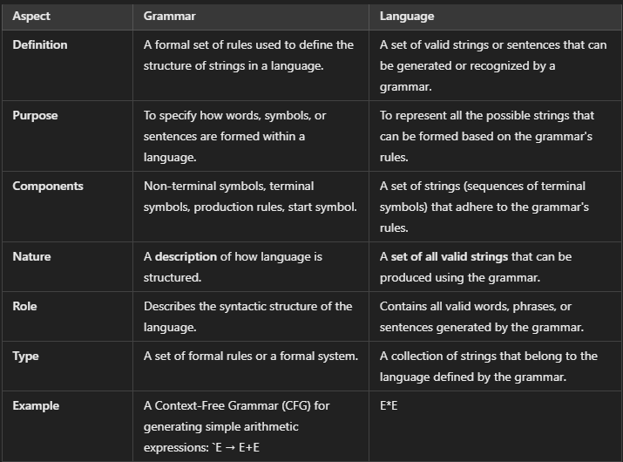

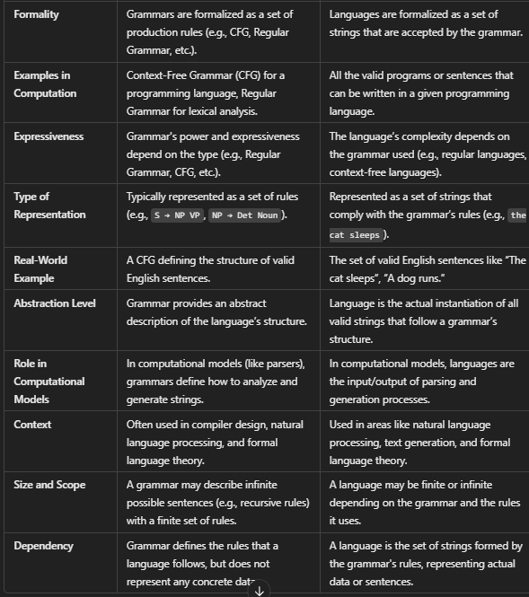

### Blocks Word Description String Generation Example as Pattern Description

In the context of **String Generation**, **Pattern Description** refers to the use of grammars and rules to describe how strings (sequences of symbols) can be generated. One such method for describing strings in a formalized way is the **Block Word Description** method, which can be used to represent or generate a sequence of words or symbols based on defined patterns.

### Block Word Description

Block word description refers to using patterns and structures to describe how sequences of words can be formed. These "blocks" represent groups of words or symbols that are generated using specific production rules or patterns. This method helps in defining a formal way to generate sequences (words, phrases, or entire sentences) by stacking blocks of rules in an organized fashion.

In pattern description, blocks are typically non-terminal symbols or groups that are expanded or generated according to predefined rules.

### Example: Block Word Description in String Generation

Let’s consider a simple example of generating a sentence using blocks that represent different parts of speech (POS) such as **noun phrases (NP)**, **verb phrases (VP)**, **articles (Det)**, **nouns (Noun)**, and **verbs (Verb)**.

#### Step 1: Define the Blocks (Parts of Speech)

Each block corresponds to a set of possible symbols (words). Here's how we can define each block:

* **NP (Noun Phrase)**: This block can consist of a **Determiner (Det)** and a **Noun**.
  + **NP → Det Noun**
* **VP (Verb Phrase)**: This block consists of a **Verb** and possibly another **NP** (i.e., a direct object).
  + **VP → Verb NP**
* **Det (Determiner)**: This block consists of words like **"the"**, **"a"**.
  + **Det → "the" | "a"**
* **Noun**: This block contains words like **"dog"**, **"cat"**.
  + **Noun → "dog" | "cat"**
* **Verb**: This block consists of action words like **"chases"**, **"catches"**.
  + **Verb → "chases" | "catches"**

#### Step 2: Combine Blocks to Form Sentences

Now, by using the rules to generate strings, we can combine these blocks to form sentences.

* **Sentence Generation**: We start with a Sentence (S) block and expand it using the rules for **NP** and **VP**.
  + **S → NP VP**
* **Expand NP**: An **NP** consists of a **Det** and a **Noun**.
  + **NP → Det Noun**
  + For example: **NP → "the" "dog"**
* **Expand VP**: A **VP** consists of a **Verb** and another **NP**.
  + **VP → Verb NP**
  + For example: **VP → "chases" "the cat"**

Combining all these, we get the final sentence:

* **S → NP VP → "the dog" "chases" "the cat"**

#### Step 3: Variations of Sentence Generation

By altering the components chosen in each block, we can generate other valid sentences based on the same pattern.

* **"a cat chases the dog"**
* **"the dog catches the cat"**
* **"a cat catches a dog"**

**Unit 4 Graphical Approaches & Grammatical Inference in Syntactic Pattern Recognition**

**Graphical Approaches:**

Definition: Graphical approaches in syntactic pattern recognition involve using graph-based structures to represent and analyze patterns within data. These approaches leverage the power of graphs to model relationships between different components of a pattern, allowing for a more flexible and comprehensive representation of complex structures. The main idea is to use nodes and edges in a graph to encapsulate the components and their relationships in the pattern.

• Graph Representation:

o Nodes: Each stroke or line segment of the character "A" can be represented as a node in a graph.

o Edges: The connections between these strokes (e.g., the angles or intersection points) can be represented as edges in the graph.

Graph Based Structural Representation:

Definition: Graph-based structural representation is a method used in syntactic pattern recognition where patterns are represented as graphs. This approach is particularly effective in capturing the structural and relational information inherent in complex patterns. In a graph-based representation, the components of a pattern are depicted as nodes, and the relationships or interactions between these components are represented as edges connecting the nodes.

Key Concepts:

• Nodes: Represent the basic elements or components of the pattern (e.g., parts of an object, characters in a string, etc.).

• Edges: Represent the relationships or connections between the components (e.g., spatial relationships, connectivity, dependencies, etc.).

• Graph Grammar: A set of rules that define how nodes and edges can be combined to form valid patterns. This method is particularly useful when the patterns have a hierarchical or relational structure that is difficult to capture with traditional feature-based approaches.

Example: Consider a scenario where you want to recognize different types of chemical molecules.

• Nodes: Each atom in the molecule can be represented as a node in the graph.

• Edges: The bonds between atoms can be represented as edges connecting the nodes. In this graph-based structural representation, the molecule's structure is captured by the graph, where the types of atoms and their bonding relationships are explicitly represented.

• Graph Grammar: The graph grammar could define the valid types of bonds (e.g., single, double, triple bonds) and how different atoms can be connected according to the rules of chemistry. This grammar helps in recognizing and differentiating between different molecules by analyzing the graph structure.

• **Image Segmentation**:

* Graphical models like **Markov Random Fields (MRFs)** and **Conditional Random Fields (CRFs)** are widely used to segment images by modeling spatial dependencies between pixels or regions.

• **Object Recognition**:

* **Graph-based models** help in recognizing and classifying objects by representing the relationships between features in a scene using graphical structures.

• **Facial Recognition**:

* **Graphical models** can represent facial features and their relationships, enabling more accurate face recognition by considering spatial relationships between facial components (eyes, nose, mouth, etc.).

• **Tracking and Motion Analysis**:

* Graphical approaches are used in tracking moving objects in video sequences by representing the object’s trajectory and motion in a graph, facilitating analysis of movements over time.

• **Handwriting Recognition**:

* **Hidden Markov Models (HMMs)** and **Bayesian networks** are applied in handwriting recognition tasks to model the sequence of strokes and their probabilistic relationships.

• **Speech Recognition**:

* **HMMs** are commonly used in speech recognition systems to model the sequence of speech sounds and their transitions, enabling the recognition of spoken words.

**Graph Isomorphism in Syntactic Pattern Recognition**

In the field of **syntactic pattern recognition**, **graph isomorphism** plays a critical role in identifying structural similarities between different patterns, often in the form of graphs. Syntactic pattern recognition involves analyzing and interpreting complex patterns (like shapes, sentences, or structures) based on their syntactic properties or rules. Graphs, due to their ability to represent relationships and hierarchical structures, are frequently used to model these patterns. In such cases, the objective is to compare different graph structures to determine whether they represent the same or similar patterns.

**Graph isomorphism** is a key concept in syntactic pattern recognition because it allows for the identification of structural equivalence between two graphs, even if the nodes or edges are labeled differently. In syntactic pattern recognition, this means recognizing whether two patterns are structurally the same,

* **Speech Recognition**: Determining if two different sentences or phrases are syntactically equivalent.
* **Object Recognition**: Recognizing objects that have different appearances but share the same underlying structure.
* **Language Processing**: Identifying grammatical equivalence in different sentence structures.
* **Natural Language Processing (NLP)**: Comparing syntactic structures of sentences (e.g., parse trees) to check for semantic similarity, despite differences in word choice.

#### **The Role of Graph Isomorphism in Syntactic Recognition**

In this context, **graph isomorphism** helps determine if two graphs, representing different syntactic structures or patterns, are essentially the same, even though they might have different labels, nodes, or edges. For example, two syntactic structures (sentences) might have different words or node labels but represent the same underlying grammatical structure.

**Example: Fingerprint Recognition**

In **fingerprint recognition**, the graph isomorphism problem can be used to compare the structure of ridge patterns between two fingerprints. The idea is to represent the ridge patterns as graphs, where:

* **Vertices** represent ridge bifurcations or endpoints.
* **Edges** represent the connections or spatial relationships between these ridge points.

To determine if two fingerprints belong to the same person, the system would look for **graph isomorphism** between the two fingerprint graphs. Even if the fingerprints are rotated or scaled, graph isomorphism allows the system to match the structural patterns of ridges, thus confirming whether the two fingerprints are identical or not.

**Process:**

1. **Graph Construction**: The fingerprint pattern is converted into a graph where the ridges' bifurcations and endings are nodes, and the spatial connections between them are edges.
2. **Isomorphism Check**: The algorithm checks if there is a one-to-one correspondence between the nodes and edges of the two graphs, considering geometric transformations (such as rotation or scaling).
3. **Matching**: If the graphs are isomorphic, the fingerprints are considered a match; otherwise, they are different.

**A Structured Strategy to Compare Attribute Graphs**

Comparing attribute graphs involves analyzing both the structural relationships (edges) and node/edge attributes to identify similarities or differences between graphs. This comparison is valuable in areas such as pattern recognition, social network analysis, and biological network comparison.

**1. Graph Pre-processing**

* **Normalization**: Standardize node and edge attributes (scaling, translation) for consistency.
* **Graph Transformation**: Simplify the graph by removing irrelevant nodes/edges or merging similar nodes.

**2. Structural Comparison**

* **Topological Structure**:
  + **Graph Isomorphism**: Check if the graphs have the same structure, ignoring labels.
  + **Subgraph Isomorphism**: Compare substructures within graphs.
  + **Graph Edit Distance**: Quantify the minimum edits needed to convert one graph into another.
* **Graph Metrics**:
  + **Degree Distribution**: Compare node degree distributions.
  + **Clustering Coefficients**: Assess local connectivity patterns.
  + **Shortest Path Lengths**: Compare the distances between node pairs.

**3. Attribute Comparison**

* **Node Attributes**:
  + **Exact Matching**: Check if node attributes are the same.
  + **Similarity Measures**: Use distance metrics (e.g., Euclidean, cosine) for attribute comparison.
  + **Attribute Weighting**: Weight attributes by importance for comparison.
* **Edge Attributes**:
  + **Edge Matching**: Compare edge attributes for correspondence.
  + **Weighted Graph Matching**: Compare edge weights to evaluate structural relationships.

**4. Global Graph Comparison**

* **Graph Centrality**: Compare node centralities (degree, betweenness) to analyze node importance.
* **Graph Similarity Index**: Calculate a score for overall structural and attribute similarity.
* **Graph Kernel Methods**: Use graph kernels to define a similarity function.
* **Graph Embedding**: Represent graphs as vectors and compare them using distance measures like cosine similarity.

**5. Handling Graph Alignment**

* **Node Alignment**: Align nodes across graphs, considering missing or extra nodes.
* **Edge Alignment**: Align edges based on both topological and attribute information.
* **Iterative Matching**: Use algorithms (e.g., Hungarian Algorithm) for iterative node and edge matching

**6. Evaluation and Reporting**

**Quantitative Evaluation**:

* + **Graph Edit Distance**: Measure required edits for graph transformation.
  + **Cosine Similarity**: Evaluate similarity of attribute vectors.
  + **Jaccard Index**: Assess intersection over union of nodes/edges.
  + **Euclidean Distance**: Compare attribute distances for nodes and edges.

**Visualization**: Create visual representations to highlight differences or similarities between graphs.

**Applications of Attribute Graph Comparison**

* **Social Network Analysis**: Comparing social networks by assessing both the structural connectivity and user attributes (e.g., interests, behaviors).
* **Biological Network Comparison**: Comparing protein interaction networks or gene networks, where nodes represent proteins or genes, and edges represent interactions or relationships.
* **Computer Vision**: Comparing object recognition graphs, where the structure represents key features of an object, and attributes represent visual characteristics.
* **Recommendation Systems**: Comparing user-item interaction graphs, where nodes represent users/items, and edges represent interactions or preferences.

### Other Attributed Graph Distance or Similarity Measures

In pattern recognition, comparing attributed graphs (graphs with additional information or attributes on nodes and edges) often requires specialized distance or similarity measures. These measures help quantify how similar or different two attributed graphs are, considering both their structure and their attributes. Below are some commonly used distance or similarity measures for attributed graphs:

#### 1. **Graph Edit Distance (GED)**

* **Description**: GED measures the minimum number of edit operations (e.g., insertion, deletion, substitution of nodes or edges) required to transform one graph into another. The edits can also take into account the attributes of nodes and edges.
* **Usage**: GED is widely used in various applications such as error-tolerant graph matching, where small differences between graphs are expected.
* **Example**: In a network of roads (represented as a graph), GED can help compare different road layouts by considering both the connections between intersections and the types of roads (attributes).

#### 2. **Subgraph Isomorphism**

* **Description**: This method checks whether one graph is a subgraph of another, meaning one graph can be mapped into a part of the other graph while preserving the structure and attributes.
* **Usage**: Subgraph isomorphism is useful in applications where you need to find patterns or motifs within a larger graph, such as in bioinformatics to identify specific molecular structures within a larger network.
* **Example**: Identifying a common sub-network in different social networks where certain attributes like "job title" or "communication frequency" match.

#### 3. **Hamming Distance (for Labeled Graphs)**

* **Description**: Hamming distance counts the number of different node or edge labels between two graphs. It’s a simple measure used when the graphs are of the same size and structure but have different labels.
* **Usage**: This is applicable in cases where only the labels or attributes differ between graphs, such as in comparing different configurations of the same network.
* **Example**: Comparing two graphs representing organizational structures where nodes represent employees and labels represent their roles.

#### 4. **Graph Spectral Distance**

* **Description**: Spectral methods use the eigenvalues of graph-related matrices (like the adjacency matrix) to compute a distance between graphs. The difference in eigenvalues or eigenvectors provides a measure of similarity or difference between the graph structures.
* **Usage**: Spectral methods are often used in graph clustering and in cases where the global structure of the graph is important.
* **Example**: Comparing the overall structure of two large social networks by analyzing the connectivity patterns rather than individual nodes or edges..

### Learning Grammars

Learning grammars in pattern recognition is a method used to model and recognize complex structures within data. It involves creating formal grammars (a set of rules) to generate or recognize patterns, particularly when the data has underlying structures, such as sequences or hierarchical arrangements. Below is an overview of how learning grammars work and their importance in pattern recognition:

#### i. **Grammars**

* **Definition**: Grammars are sets of rules or productions used to describe how strings (or patterns) are generated.
* **Role in Pattern Recognition**: In pattern recognition, grammars describe how certain patterns are formed, allowing systems to both generate valid patterns and recognize them in data.

#### ii. **Types of Grammars**

* **Regular Grammars**: Used for simpler pattern structures, like sequences.
* **Context-Free Grammars (CFGs)**: Useful for hierarchical structures, such as those in natural language or certain image recognition tasks.
* **Context-Sensitive Grammars**: Handle even more complex dependencies between parts of patterns.
* **Stochastic Grammars**: Assign probabilities to different production rules, helping with the recognition of patterns that are inherently probabilistic (like speech or handwritten text).

#### iii. **Learning Grammars Approaches**

* **Supervised Learning**: Grammar rules are learned by training a model on a labeled dataset where the patterns and their corresponding classes are known. This is common in fields like natural language processing (NLP).
* **Unsupervised Learning**: The system tries to infer grammatical rules directly from the data without explicit labels. Techniques like clustering and generative models can help in this process.
* **Inductive Grammar Learning**: The model induces grammar rules from examples and counterexamples of patterns. It is especially useful for tasks where clear rules can be derived from a few instances.

**Learning Grammar Process**

Here’s a simplified process to learn grammars:

1. *Understand Grammar Basics*: Learn about terminals, non-terminals, production rules, and start symbols.

2. *Study Grammar Types: Focus on the **Chomsky Hierarchy*:

- Type 3: Regular (simplest, used in regex).

- Type 2: Context-Free (used in programming languages).

- Type 1: Context-Sensitive.

- Type 0: Unrestricted (most powerful).

3. *Practice Derivations*: Use rules to generate strings. Example: \( S → aSb | ε \) derives \( aabb \).

4. *Learn Applications*: Explore use cases in:

- Programming languages (parsers, compilers).

- Regular expressions.

- Natural language processing (NLP).

5. *Use Tools*: Experiment with tools like ANTLR, YACC, or JFLAP to design and test grammars.

6. *Build Projects*: Create simple parsers or interpreters to apply what you’ve learned.

7. *Advance Gradually*: Study parsing techniques and normalization (e.g., Chomsky Normal Form).

### Problem Formulation in Pattern Recognition

The problem formulation in pattern recognition is a crucial step that mathematically and conceptually frames the task of recognizing patterns from data. It defines the goals, inputs, outputs, and methods needed to solve the pattern recognition problem. A proper problem formulation aids in designing better algorithms, selecting appropriate models, and evaluating their performance. Below is a breakdown of how the process is typically structured:

#### 1. **Pattern Recognition Problem Definition**

The primary goal of pattern recognition is to classify data (input patterns) into one of several predefined categories (classes). The task is to find a mapping from the input space to a set of labels or decisions. Formally, the problem can be defined as:  
Given an input space XXX (feature space) and a finite set of possible classes YYY (label space), find a function f:X→Yf: X \to Yf:X→Y that assigns the correct label to each input instance.

#### 2. **Key Components of Problem Formulation**

##### a. **Input Representation (Feature Space)**

The first step is to represent each data sample (pattern) using features. Features describe the data in a way that can be processed by the recognition system. These features are usually vectors containing numerical, categorical, or binary values derived from the raw data.  
**Examples of features:**

* **For image recognition**: color histograms, edges, textures.
* **For speech recognition**: frequency.
* **For text classification**: word frequencies, word embeddings.

##### b. **Class Labels (Output Space)**

The output of the pattern recognition system is the class label associated with the input pattern. Classes can be either discrete or continuous, depending on the type of recognition problem.  
**Examples of classes:**

* **Handwritten digit recognition**: the digits 0 to 9.
* **Object recognition in images**: car, person, tree, etc.
* **Disease classification**: healthy, disease A, disease B.

##### c. **Classification Function**

The problem requires finding or learning a decision function that can map the input features to one of the class labels. This function is generally unknown and is learned from a dataset of labeled examples.

* **Supervised Learning**: Most pattern recognition problems are framed as supervised learning tasks, where the classifier is trained using a set of labeled examples (training data).
* **Unsupervised Learning**: In some cases, the classes may not be predefined, and the task is to group similar patterns together (clustering).
* **Semi-supervised or Reinforcement Learning**: both of above

##### d. **Error Function / Objective Function**

In pattern recognition, a classifier's performance is evaluated based on how well it assigns the correct class labels to new, unseen input patterns. The error or objective function is used to evaluate this performance.  
**Examples of error functions:**

* **Classification error**: The proportion of misclassified instances.
* **Log-likelihood**: Used in probabilistic models like Bayesian classifiers.
* **Cross-entropy loss**: Common in neural networks.

### Approaches to Solving the Problem

#### a. **Statistical Methods**

* **Bayesian Classifiers**: Classify based on posterior probabilities using Bayes' theorem.
* **Maximum Likelihood Estimation (MLE)**: Estimate parameters that maximize the likelihood of observed data.
* **Discriminant Analysis**: Use linear or quadratic functions to separate classes in feature space.

#### b. **Geometrical Methods**

* **Linear Classifiers**: Linear SVM and Perceptron for class separation.
* **Non-linear Classifiers**: Kernel SVM and Neural Networks for complex class boundaries.

#### c. **Structural Methods**

* **Grammatical Approaches**: Use grammars for parsing complex patterns (e.g., language data).
* **Graph-based Approaches**: Graph matching for tasks like handwriting or protein structure recognition.

#### d. **Neural Networks and Deep Learning**

* **CNNs for Image Classification**: Learn spatial features for image recognition.
* **RNNs/LSTMs for Sequence-based Data**: Model sequences for tasks like speech or time-series analysis.

### Challenges in Problem Formulation

#### a. **Dimensionality of Feature Space**

High-dimensional feature spaces can lead to issues like the "curse of dimensionality," where the number of features is much larger than the available data, causing overfitting.

#### b. **Imbalanced Data**

In some cases, certain classes may have far fewer examples than others, leading to biased classifiers. Special techniques like oversampling, undersampling, or cost-sensitive learning are often necessary to handle imbalanced data.

#### c. **Noise and Variability in Data**

Real-world data typically contains noise, missing values, or variability in how patterns appear. Handling this variability effectively is crucial to improving model robustness and accuracy.

#### d. **Overfitting and Generalization**

Balancing model complexity is essential. A model that is too complex may overfit the training data, capturing noise and leading to poor generalization when exposed to new, unseen data. Proper regularization and cross-validation techniques are necessary to prevent overfitting.

### Grammatical Inference (GI) Approaches in Pattern Recognition

Grammatical Inference (GI) involves learning a formal grammar or automaton from observed data or patterns. The goal is to infer rules or models that can generate or recognize patterns from given sequences. GI approaches are useful in various domains such as speech recognition, bioinformatics, natural language processing, and handwriting recognition. Below are the key GI approaches:

#### 1. **State-based Approaches**

State-based GI techniques aim to infer automata, such as finite-state machines (FSM), that model the sequences or patterns observed in the data. These methods rely on defining states and transitions based on input sequences. The automaton captures the relationship between symbols or events in a sequence, making it easier to classify or generate similar sequences.

* **Applications**:
  + **Speech Recognition**: Modeling speech patterns using state machines to classify phonemes or words.
  + **Bioinformatics**: Modeling biological sequences, such as DNA or protein sequences, with FSMs to identify gene patterns or protein structures.
* **Key Characteristics**:
  + Focuses on sequential data.
  + Can handle sequences of varying lengths.
  + Suitable for real-time recognition tasks.

#### 2. **Rule-based Approaches**

Rule-based GI methods focus on inferring a set of production rules that define a formal grammar. These rules describe how to generate valid patterns from a set of symbols or elements. The inferred grammar can be applied to generate new data patterns or recognize existing ones in an automated fashion.

* **Applications**:
  + **Natural Language Processing (NLP)**: Inferring syntactic or semantic rules from large corpora of text to process and understand language.
  + **Pattern Generation**: Creating new patterns based on inferred grammatical structures, useful in creative domains like music composition or automated design.
* **Key Characteristics**:
  + Works well for structured data with clear syntactical patterns.
  + Focuses on learning generative rules.
  + Can be extended to handle more complex data structures through context-free or context-sensitive grammars.

#### 3. **Statistical Approaches**

Statistical GI methods involve learning probabilistic models from data, such as Hidden Markov Models (HMMs) or Stochastic Context-Free Grammars (SCFGs). These models capture the inherent uncertainty and variability in the data, making them particularly useful for noisy, incomplete, or uncertain data sources. Learns probabilistic relationships between symbols.

* **Applications**:
  + **Speech Recognition**: Using HMMs to model the probabilistic relationships between speech sounds and words.
  + **Handwriting Recognition**: Applying stochastic models to interpret handwritten characters or words that may be noisy or inconsistent.
  + **Bioinformatics**: Using probabilistic models to understand gene expression patterns or protein folding dynamics.
* **Key Characteristics**:
  + Handles noise and uncertainty in data.
  + Learns probabilistic relationships between symbols.
  + Useful for sequential or time-series data.

#### 4. **Hybrid Approaches**

Hybrid GI approaches combine multiple techniques, such as state-based models, rule-based methods, and statistical learning, to leverage the strengths of each. These approaches are especially effective when dealing with complex pattern recognition tasks where no single method can adequately capture all aspects of the data. Hybrid methods aim to improve performance, robustness, and flexibility.

* **Applications**:
  + **Complex Pattern Recognition**: Integrating state-based models with statistical learning in applications like speech-to-text systems, where both temporal dependencies and statistical variations are crucial.
  + **Multimodal Recognition**: Combining visual, auditory, and textual data for tasks like automatic image captioning or multi-sensory human-computer interaction.
* **Key Characteristics**:
  + Combines the advantages of different techniques.
  + Can adapt to more diverse and complex data.
  + Improves generalization by addressing different types of patterns or data modalities.

### Procedures to Generate Constrained Grammars in Pattern Recognition

Generating constrained grammars is essential for modeling structured patterns, such as sequences in language processing, biometric data, or biological patterns. The goal is to develop grammars that generate only valid patterns under specific constraints. Below are the steps involved in generating constrained grammars:

#### 1. **Define the Pattern Class and Constraints**

* **A. Determine the desired patterns**:  
  Choose the type of patterns (e.g., shapes, sound signals, or text sequences) that you wish to recognize.
* **B. Establish limitations**:  
  Set rules that limit the set of acceptable patterns, such as specific lengths, repetition structures, or boundary requirements.  
  This could involve restrictions on shape features in image recognition or phoneme sequences in speech recognition.
* **C. Include a noise tolerance clause**:  
  Since noise is common in real-world data, include some flexibility in the grammar to handle pattern variability, ensuring that noise is tolerated.

#### 2. **Choose an Appropriate Grammar Formalism**

Select the grammar type based on the complexity of the patterns and constraints:

* **Regular Grammars**:  
  Useful for simple and repetitive patterns, such as recognizing alternating sequences (e.g., ab*).
* **Context-Free Grammars (CFG)**:  
  Suitable for more structured, hierarchical patterns, like recognizing valid nested parentheses or tree-like structures in syntax parsing.
* **Context-Sensitive Grammars (CSG)**:  
  Apply when the recognition depends on the context of surrounding elements (e.g., protein sequences in bioinformatics).
* **Stochastic/Probabilistic Grammars**:  
  Useful in real-world pattern recognition tasks where uncertainties are present. For instance, probabilistic context-free grammars (PCFGs) are often applied in speech recognition to model variations in speech patterns.

#### 3. **Identify Terminals and Non-Terminals**

* **Terminals**:  
  These represent the raw data elements or observed symbols, such as phonemes, pixels, or nucleotide bases. Terminals are the basic units of the pattern.
* **Non-Terminals**:  
  These capture abstract features or larger components of the pattern, such as syllables in speech or geometric shapes in images.

**Example**:

* **Terminals**: {a, b}
* **Non-terminals**: <S> for sequences, <A> for alternating structures.

#### 4. **Define Production Rules**

Create production rules that reflect the structure of the pattern. These rules define how non-terminals expand into terminals or other non-terminals. The rules can also enforce constraints, such as:

* Order of symbols
* Repetitions
* Structural properties (e.g., nested patterns or symmetric features)

**Example**:

* For a pattern where an object is composed of specific parts:

php

Copy code

<object> ::= <part> <object> | ε

* For recognizing alternating signals: <A> ::= a <B> | b <A>

<B> ::= b <A> | ε

#### 5. **Incorporate Constraints into the Grammar**

* **Length constraints**:  
  Limit the grammar to generate sequences or patterns of specific lengths. For example, in a grammar modeling biological sequences, you might constrain the grammar to ensure a fixed number of codons.
* **Structural constraints**:  
  Apply conditions like:
  + "Every opening bracket must have a closing bracket."
  + "Each phoneme must follow a specific set of others based on language rules."
* **Symbol frequency constraints**:  
  Ensure certain symbols or patterns occur with a specific frequency or in a particular order. For example, restrict a text pattern to require repeated characters at specified intervals.

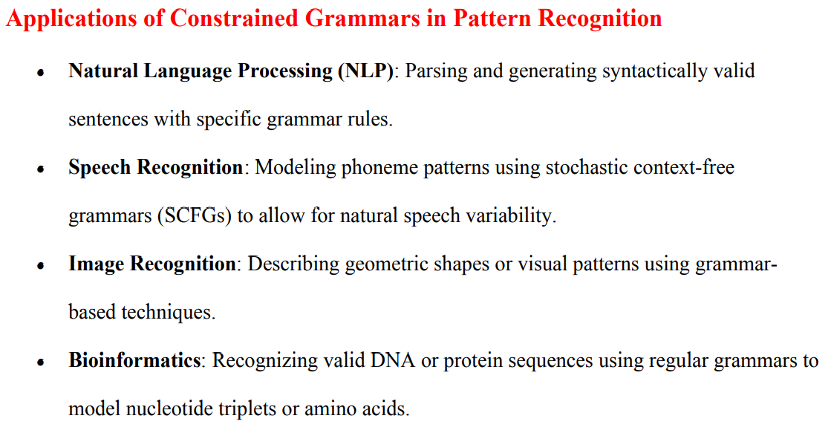

QUESTION

Analyze different application of Relational Graph to Pattern Recognition?[8]

Relational Graphs (RGs) are powerful tools in pattern recognition, as they can model complex relationships between different elements of data. They represent patterns as nodes connected by edges, where nodes correspond to features or objects, and edges represent relationships or interactions between them. The flexibility of relational graphs allows them to be applied in various domains of pattern recognition. Below are the different applications of Relational Graphs to pattern recognition:

### 1. ****Image Recognition and Computer Vision****

* **Object Recognition**: Relational graphs can represent spatial relationships between objects in an image. By constructing graphs where nodes represent object parts and edges represent geometric or relational features (e.g., distance, adjacency), the model can identify the global structure of objects. These graphs allow for robust recognition under various transformations such as scaling, rotation, or occlusion.
* **Scene Understanding**: In complex scenes with multiple interacting objects, relational graphs help in understanding the contextual relationships between objects. For instance, a graph could model the relationship between a person, a chair, and a table to determine their spatial and functional interactions.

**Example**: In face recognition, a relational graph can model the relationship between facial features like the eyes, nose, and mouth, capturing their spatial relations to recognize individuals under different conditions.

### 2. ****Handwriting and Document Recognition****

* **Handwritten Character Recognition**: Relational graphs can be used to recognize handwritten characters by representing each character as a graph of strokes or components. The edges represent spatial or directional relationships between segments of the characters. This is especially useful in recognizing cursive or highly varied handwriting.
* **Document Structure Recognition**: In optical character recognition (OCR), relational graphs can model the layout of a document, capturing the relationships between lines, words, paragraphs, and blocks of text. This helps in tasks such as document segmentation and layout analysis, facilitating better extraction of structured information from scanned documents.

### 3. ****Natural Language Processing (NLP)****

* **Syntactic Parsing**: In NLP, relational graphs are frequently used to model sentence structures. Syntax trees or dependency graphs represent grammatical relationships between words in a sentence, with nodes as words and edges representing syntactic dependencies. This structure aids in parsing sentences and extracting semantic meaning.
* **Semantic Graphs**: Relational graphs can also be used to represent the relationships between words or concepts in a sentence or document, enabling better understanding of meaning and context. For example, in knowledge graphs, entities (nodes) are linked by relationships (edges) that represent facts or connections, aiding in tasks like question answering and information retrieval.

### 4. ****Biometric Recognition****

* **Fingerprint Recognition**: Relational graphs can model the minutiae points in a fingerprint, with nodes representing individual minutiae and edges representing the spatial relationships between them. This can be used to match and verify fingerprints even with noise or partial information.
* **Face Recognition**: Similar to image recognition, relational graphs can be used to capture the relationships between facial features, providing a robust method for matching faces under varying conditions such as lighting, pose, and expression.

**Example**: In iris recognition, relational graphs can represent the relationship between key points of the iris texture, aiding in more accurate matching.

### 5. ****Bioinformatics and Computational Biology****

* **Protein-Protein Interaction (PPI) Networks**: In bioinformatics, relational graphs are used to model the interactions between proteins in a biological system. Proteins are represented as nodes, and edges represent interactions between them. This helps in understanding biological pathways, predicting protein functions, and discovering new drug targets.
* **Genomic Sequence Analysis**: Relational graphs can be used to model relationships between nucleotides or genes in genomic sequences. These graphs help in identifying conserved regions, mutations, or structural variations, aiding in gene prediction and disease association studies.

### 6. ****Social Network Analysis****

* **Community Detection**: In social networks, relational graphs are used to represent individuals (nodes) and their relationships (edges), such as friendships or interactions. Graph-based techniques can identify communities or clusters of closely connected individuals, useful for tasks like target marketing, recommendation systems, or detecting communities in social media.
* **Influence Propagation**: Relational graphs are also used to model the spread of information or influence in social networks. By examining the relationships between nodes, one can predict how information or behaviors propagate through the network, useful for viral marketing or detecting trends.

### 7. ****Speech and Audio Recognition****

* **Phoneme and Speech Pattern Recognition**: Relational graphs are applied to model the relationships between different phonemes in speech recognition. Each phoneme can be represented as a node, and edges represent the transitions between phonemes based on temporal or contextual information. This helps in identifying words or phrases in continuous speech.
* **Speaker Identification**: In speaker recognition, relational graphs can be used to represent features extracted from speech signals, such as pitch, tone, and cadence, where relationships between these features are modeled to differentiate speakers.

### 8. ****Robotics and Autonomous Systems****

* **Path Planning and Navigation**: Relational graphs are used to represent environments and obstacles in robotics. Nodes represent locations, and edges represent possible movements or paths. This helps robots navigate through complex environments by identifying the optimal path or avoiding collisions.
* **Object Manipulation**: In robotic object manipulation, relational graphs can model the relationships between objects in the robot's workspace. By understanding how objects interact with each other, the robot can plan actions such as picking up, moving, or assembling objects.

### Canonical Definite Finite State Grammar (CDFSG)

A **Canonical Definite Finite State Grammar (CDFSG)** is a type of formal grammar used to describe a finite set of strings or a language that can be recognized by a finite state machine (FSM). In CDFSG, each rule (production) is "definite," meaning that the grammar strictly defines the transitions in terms of a fixed state and specific symbols. It is a restricted version of a context-free grammar but more structured, making it useful in applications like lexical analysis or text parsing.

#### Key Characteristics of CDFSG:

1. **Finite States**: The grammar operates with a finite set of states.
2. **Definite Productions**: Each production or rule has a specific, unambiguous transition from one state to another.
3. **Deterministic**: The grammar is deterministic, meaning for a given input, there is only one possible way to apply the grammar.
4. **Non-ambiguous**: The grammar avoids ambiguities in how strings can be derived.

**Representation of**

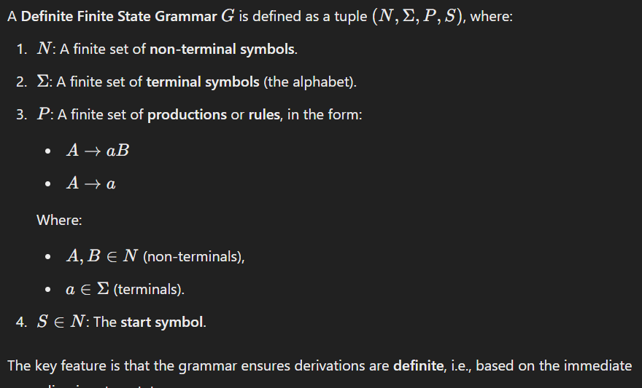

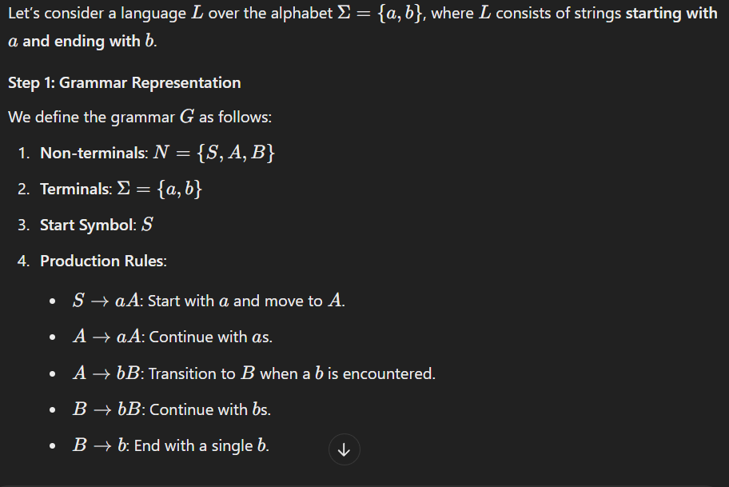

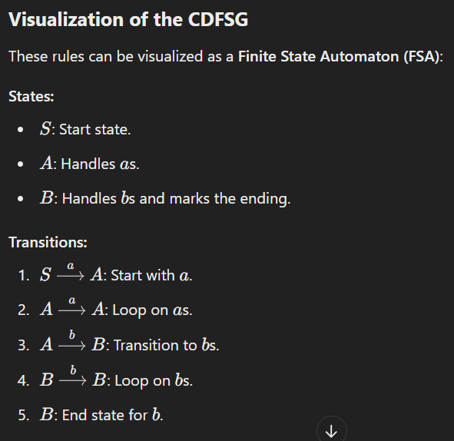

#### Components of CDFSG:

* **States**: Represent the different stages in the process of recognizing or generating strings.
* **Alphabet**: The set of symbols that can be used in the input.
* **Transitions**: Defined rules that specify how states move based on the input symbols.
* **Start State**: The initial state from where parsing begins.
* **Accept States**: States that represent the successful recognition of a string.

### Use Cases:

1. **Lexical Analysis**: CDFSGs are used in compilers to recognize tokens in a programming language (e.g., keywords, operators).
2. **Pattern Recognition**: CDFSGs can be used to recognize simple patterns in sequences of symbols.
3. **Text Parsing**: CDFSGs can be used to recognize grammatical structures in text.

### ****Clique Finding Algorithm****

In graph theory, a **clique** is a subset of vertices in a graph such that every two distinct vertices are adjacent to each other. Finding cliques in a graph is important in applications like social network analysis, bioinformatics, and community detection.

One of the most common algorithms for finding cliques in a graph is the **Bron–Kerbosch algorithm**. This algorithm efficiently finds all **maximal cliques** in an undirected graph.

### ****Steps of the Bron-Kerbosch Algorithm****

The Bron–Kerbosch algorithm works by recursively finding all maximal cliques in the graph. It operates on three sets:

* **R**: The current clique being built.
* **P**: The set of candidate vertices that can be added to the current clique.
* **X**: The set of vertices already considered but not included in the clique.

#### **Base Case:**

If **P** and **X** are both empty, the current clique **R** is a maximal clique, and it should be recorded.

#### **Recursive Case:**

For each vertex **v** in **P**:

1. Add **v** to the current clique **R**.
2. Update **P** to include only the neighbors of **v** that are still in **P** (i.e., **P ∩ N(v)**).
3. Update **X** to include only the neighbors of **v** that are already in **X** (i.e., **X ∩ N(v)**).
4. Remove **v** from **P** and add it to **X**.

### ****Example:****

Consider the following undirected graph:

A

/ \

B - C

\ /

D

* **Vertices**: A, B, C, D
* **Edges**: AB, AC, BC, BD, CD

We want to find the maximal cliques in this graph using the Bron–Kerbosch algorithm.

1. **Initialization**:
   * **R = {}** (initial clique is empty)
   * **P = {A, B, C, D}** (all vertices are candidates)
   * **X = {}** (no vertices have been excluded yet)
2. **First Recursion** (Start with vertex **A**):
   * **P = {A, B, C, D}**, **R = {}**, **X = {}**
   * Pick **A** and add it to **R**: **R = {A}**
   * Update **P** to the neighbors of **A**: **P = {B, C}**
   * **X = {}** (no excluded vertices yet)
3. **Second Recursion** (Start with vertex **B**):
   * **P = {B, C}**, **R = {A}**, **X = {}**
   * Pick **B** and add it to **R**: **R = {A, B}**
   * Update **P** to the neighbors of **B** that are also in **P**: **P = {C}**
   * **X = {}** (no excluded vertices yet)
4. **Third Recursion** (Start with vertex **C**):
   * **P = {C}**, **R = {A, B}**, **X = {}**
   * Pick **C** and add it to **R**: **R = {A, B, C}**
   * Update **P** to the neighbors of **C** that are also in **P**: **P = {}** (no remaining candidates)
   * **P is empty**, so **{A, B, C}** is a maximal clique.
5. **Backtracking**:
   * Backtrack and continue from the previous recursive level. In this case, the algorithm explores other possibilities for cliques.
6. **Final Result**: The algorithm identifies the following maximal cliques:
   * **{A, B, C}**
   * **{B, C, D}**
   * **{A, B}**
   * **{C, D}**
   * **{A, C}**

### ****Complexity of the Algorithm****

The worst-case time complexity of the **Bron–Kerbosch algorithm** is **O(3^(n/3))**, where **n** is the number of vertices. This complexity arises because the algorithm explores potential cliques recursively, and in dense graphs, it may examine many possible cliques. However, it performs well in sparse graphs.

### ****Applications of Clique Finding****

1. **Community Detection in Social Networks**:  
   Finding cliques helps identify tightly-knit groups of people or nodes within a network who are all connected to each other. For example, detecting communities in social media or collaboration networks.
2. **Gene Co-expression Networks**:  
   In bioinformatics, cliques in gene co-expression networks can reveal genes that are co-expressed under similar conditions and may be functionally related.
3. **Image Segmentation**:  
   In computer vision, clique finding can help segment an image into regions that are densely connected, helping identify meaningful components or objects within the image.
4. **Subgraph Matching**:  
   Finding subgraphs that match specific patterns or motifs is crucial in tasks such as protein interaction analysis or identifying recurring structures in large datasets.

### ****Draw and Explain Grammatical Interface Model and its objectives. [8]****

### ****Grammatical Interface Model****

The **Grammatical Interface Model** is a conceptual framework used in pattern recognition and natural language processing (NLP) for representing how a grammar can interact with different components of a system. This model typically involves the application of formal grammars to recognize patterns in structured data, such as text or other symbolic information. The primary objective of this model is to provide a systematic way to map a set of rules (grammar) to the underlying structure of the data.

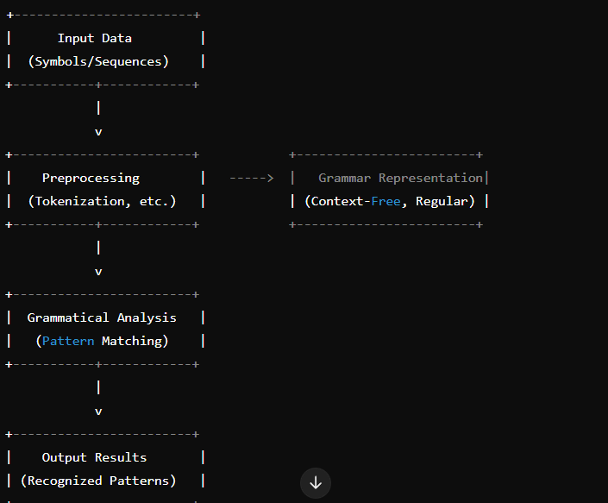

### ****Explanation of the Components:****

1. **Input Data**:  
   The model begins with raw input data, which can be in the form of sequences, symbols, or structures (e.g., text, images, speech signals). The data is unprocessed and may contain noise or irrelevant information.
2. **Preprocessing**:  
   The preprocessing phase is crucial for transforming raw data into a format that can be handled by the grammar-based system. This may include operations like tokenization (breaking text into words or symbols), normalization, noise reduction, or feature extraction. The goal is to make the data suitable for grammatical analysis.
3. **Grammar Representation**:  
   This component involves representing the patterns or structures using formal grammars. A grammar defines the syntax and rules for valid patterns. The grammar can be:
   * **Context-Free Grammar (CFG)**: Useful for hierarchical structures, such as language parsing.
   * **Regular Grammar**: Useful for recognizing simple, repetitive patterns.
   * **Probabilistic Grammar (e.g., PCFG)**: Used when there is uncertainty or probabilistic relationships between patterns.
   * **CSG**;more complex terminal or nonterminal may be one or more
4. **Grammatical Analysis**:  
   Once the data is preprocessed and the grammar is defined, the next step is to perform grammatical analysis. In this phase, the system tries to match the input data with the patterns described by the grammar. It checks whether the input follows the rules and can generate valid structures or sequences.
5. **Output Results**:  
   Finally, the system produces the output, which is a recognition of patterns from the input data. These recognized patterns could be specific sequences (e.g., in text or speech) or structural relationships (e.g., identifying certain objects or features in images).

### ****Objectives of the Grammatical Interface Model:****

1. **Pattern Recognition**:  
   The primary objective of the Grammatical Interface Model is to identify patterns or regularities in structured data. For example, in NLP, it helps identify valid sentences based on syntactic rules, while in bioinformatics, it can recognize patterns in genetic sequences.
2. **Mapping Complex Patterns**:  
   It allows mapping complex patterns to a set of formal rules that can be systematically analyzed and recognized. This is particularly useful in areas like language processing, image analysis, and genetic sequence recognition.
3. **Handling Structure and Hierarchy**:  
   The model can effectively handle structured or hierarchical data by using grammars like Context-Free Grammar, which can represent nested structures (e.g., parentheses in programming languages or hierarchical sentence structures in language).
4. **Flexibility and Adaptability**:  
   The Grammatical Interface Model is flexible enough to be adapted for different types of data, including speech, text, images, and biological sequences. By adjusting the grammar and preprocessing steps, the model can be applied across a wide range of domains.
5. **Error Handling and Robustness**:  
   Through the use of formal grammars, the model can incorporate error detection and correction mechanisms. This is particularly useful in noisy or uncertain environments, such as speech recognition or text transcription.
6. **Optimization**:  
   The model helps in optimizing the process of pattern matching and recognition. By using well-defined grammar rules, the system can efficiently match patterns with a reduced number of possible solutions, speeding up the recognition process.

### ****Applications:****

* **Natural Language Processing (NLP)**: Used for parsing sentences and recognizing syntactic structures in text.
* **Speech Recognition**: To identify valid phoneme sequences in spoken language.
* **Bioinformatics**: Recognizing specific motifs or patterns in DNA or protein sequences.
* **Image Recognition**: Segmenting images based on grammatical rules applied to pixel structures.

### Identifying Isomorphism Between Two Graphs G1G_1G1​ and G2G_2G2​ with ppp Nodes

**Graph Isomorphism** is a concept in graph theory where two graphs are considered isomorphic if there is a one-to-one correspondence between their nodes and edges, such that the connectivity (adjacency) between the nodes is preserved.

In other words, two graphs G1G_1G1​ and G2G_2G2​ are **isomorphic** if there is a way to relabel the nodes of G1G_1G1​ so that it becomes identical to G2G_2G2​ in terms of connectivity.

### Procedure to Identify Isomorphism

Given two graphs G1=(V1,E1)G_1 = (V_1, E_1)G1​=(V1​,E1​) and G2=(V2,E2)G_2 = (V_2, E_2)G2​=(V2​,E2​), where V1V_1V1​ and V2V_2V2​ are the sets of vertices (nodes) and E1E_1E1​ and E2E_2E2​ are the sets of edges, the following steps are involved in determining if G1G_1G1​ and G2G_2G2​ are isomorphic:

#### 1. **Check Number of Nodes and Edges**:

* The first condition for isomorphism is that both graphs must have the same number of nodes ppp and the same number of edges.
* If ∣V1∣≠∣V2∣|V_1| \neq |V_2|∣V1​∣=∣V2​∣ or ∣E1∣≠∣E2∣|E_1| \neq |E_2|∣E1​∣=∣E2​∣, then the graphs are not isomorphic.

#### 2. **Check Degree Sequences**:

* **Degree sequence** is a list of the degrees (number of edges incident to a node) of the nodes in the graph.
* If the degree sequences of the two graphs G1G_1G1​ and G2G_2G2​ are different, then the graphs are not isomorphic.
* Sort the degree sequences and compare them. If they are not identical, G1G_1G1​ and G2G_2G2​ are not isomorphic.

#### 3. **Check for Possible Node Matching**:

* If the degree sequences are identical, try to establish a one-to-one correspondence between the nodes of G1G_1G1​ and G2G_2G2​ based on their degrees.
* A node in G1G_1G1​ with a certain degree should correspond to a node in G2G_2G2​ with the same degree.

#### 4. **Check Edge Correspondence**:

* For the chosen node matching, check if the adjacency relations (edges) are preserved. Specifically:
  + If node uuu in G1G_1G1​ is adjacent to nodes v1,v2,…v_1, v_2, \dotsv1​,v2​,…, then the corresponding node u′u'u′ in G2G_2G2​ must be adjacent to nodes v1′,v2′,…v_1', v_2', \dotsv1′​,v2′​,… (where v1′,v2′,…v_1', v_2', \dotsv1′​,v2′​,… are the corresponding nodes of v1,v2,…v_1, v_2, \dotsv1​,v2​,… based on the one-to-one mapping).

#### 5. **Graph Automorphism**:

* If a mapping satisfies all the above conditions, you have found a graph isomorphism between G1G_1G1​ and G2G_2G2​.
* If such a mapping cannot be established, then the graphs are not isomorphic.

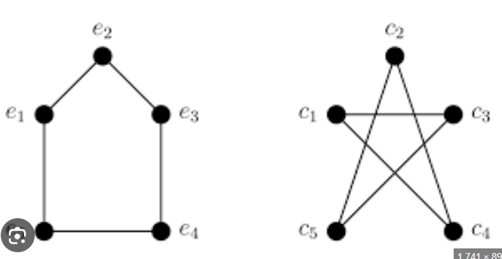

### Example:

Consider two graphs G1G_1G1​ and G2G_2G2​, each with 3 nodes.

* **Graph G1G_1G1​:**
  + Nodes: v1,v2,v3v_1, v_2, v_3v1​,v2​,v3​
  + Edges: (v1,v2),(v2,v3),(v3,v1)(v_1, v_2), (v_2, v_3), (v_3, v_1)(v1​,v2​),(v2​,v3​),(v3​,v1​)
  + Degree sequence: [2, 2, 2]
* **Graph G2G_2G2​:**
  + Nodes: u1,u2,u3u_1, u_2, u_3u1​,u2​,u3​
  + Edges: (u1,u2),(u2,u3),(u3,u1)(u_1, u_2), (u_2, u_3), (u_3, u_1)(u1​,u2​),(u2​,u3​),(u3​,u1​)
  + Degree sequence: [2, 2, 2]

Since the degree sequences are identical, we can attempt to find a one-to-one correspondence between the nodes.

* Corresponding nodes: v1↔u1,v2↔u2,v3↔u3v_1 \leftrightarrow u_1, v_2 \leftrightarrow u_2, v_3 \leftrightarrow u_3v1​↔u1​,v2​↔u2​,v3​↔u3​.
* Edges in G1G_1G1​: (v1,v2),(v2,v3),(v3,v1)(v_1, v_2), (v_2, v_3), (v_3, v_1)(v1​,v2​),(v2​,v3​),(v3​,v1​).
* Edges in G2G_2G2​: (u1,u2),(u2,u3),(u3,u1)(u_1, u_2), (u_2, u_3), (u_3, u_1)(u1​,u2​),(u2​,u3​),(u3​,u1​).

As the edges correspond perfectly between G1G_1G1​ and G2G_2G2​, **the graphs are isomorphic**.

### Design and Selection of Similarity Measures

1. **Data Type and Domain**: Choose based on data type (numerical, text, graph) and domain knowledge. For example, use **Euclidean distance** for numerical data and **Cosine similarity** for text data.
2. **Similarity vs. Dissimilarity**: Similarity measures quantify likeness (e.g., **Cosine similarity**), while dissimilarity measures quantify difference (e.g., **Euclidean distance**).
3. **Computational Complexity**: Consider efficiency for large datasets. **Euclidean distance** is computationally simpler, while **Graph edit distance** is more complex.
4. **Robustness**: Choose measures that are robust to noise and outliers. For example, **Manhattan distance** is less sensitive to outliers than **Euclidean distance**.
5. **Interpretability**: The measure should be understandable in the context of the problem, like how clusters are formed in clustering tasks.
6. **Scalability**: Ensure the measure scales well for large datasets. **Cosine similarity** is efficient for high-dimensional data like text.
7. **Flexibility**: Consider if the measure needs to be adapted or combined for the specific task (e.g., **weighted Euclidean distance**).
8. **Task-Specific Selection**: For classification, use distance measures like **Euclidean distance** in **k-NN**; for clustering, measures like **average linkage** are used.
9. **Performance Evaluation**: Test the measure using empirical methods like **cross-validation** and task-specific metrics (e.g., **F1-score**).

HOMOMORPHISM VS ISOMORPHISM

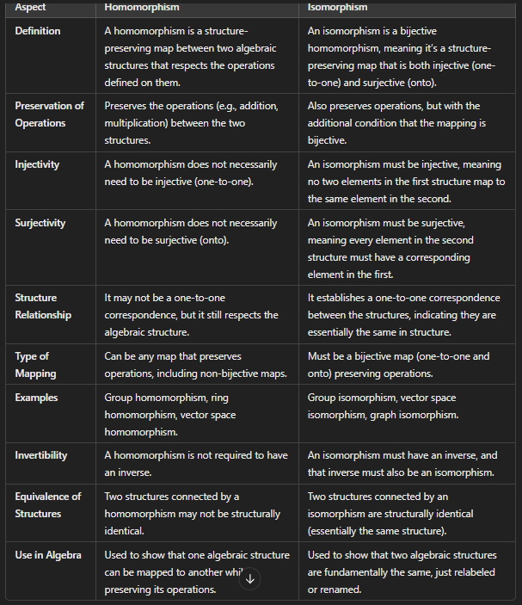

**UNIT 5**

**Introduction to Neural Networks: Neurons and Neural Nets**

Neural networks are a class of machine learning models inspired by the structure and functioning of the human brain. These networks are designed to recognize patterns and make predictions based on data. They are particularly powerful for tasks such as image recognition, speech recognition, natural language processing, and even in complex fields like robotics and healthcare.

### ****1. Neurons: The Building Blocks of Neural Networks****

A **neuron** in a neural network is a mathematical function that takes one or more inputs, processes them, and produces an output. It is analogous to biological neurons, which receive electrical signals from other neurons, process the information, and send out a signal to other neurons.

A simple **artificial neuron** consists of the following components:

* **Input (x₁, x₂, ..., xn)**: These are the features of the data that the neuron will process. For example, in an image recognition task, the inputs could be pixel values of an image.
* **Weights (w₁, w₂, ..., wn)**: Each input has an associated weight that represents its importance in the decision-making process. These weights are learned during the training process.
* **Bias (b)**: This is an additional parameter that allows the neuron to shift the activation function. It helps the model make decisions that are not strictly based on the weighted sum of the inputs.
* **Activation Function (f)**: This is a mathematical function that determines the output of the neuron. It introduces non-linearity into the network, which is essential for learning complex patterns.

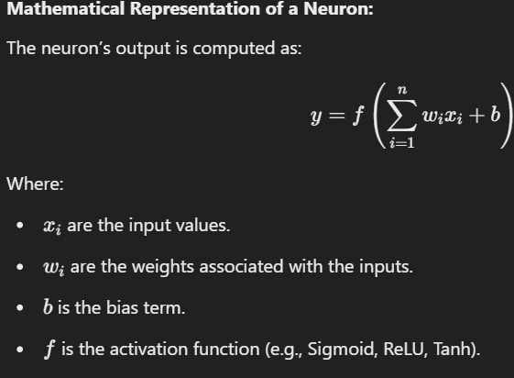

### ****2. Neural Networks: A Collection of Neurons****

A **neural network** is a collection of multiple neurons arranged in layers. The most basic type of neural network is a **feedforward neural network**, where information flows in one direction, from input to output, without loops.

Neural networks can be composed of three main types of layers:

1. **Input Layer**: This layer receives the input features of the data. For example, in an image classification task, the input layer will take pixel values of the image.
2. **Hidden Layers**: These are layers between the input and output layers. The hidden layers perform the computations and transformations needed to learn patterns in the data. A neural network can have multiple hidden layers, and these layers are where most of the learning happens.
3. **Output Layer**: This layer produces the final output of the network. For example, in a classification task, the output layer may have one neuron per class, and the output values represent the probabilities of each class.

### ****Types of Neural Networks****

* **Feedforward Neural Networks (FNNs)**: Data flows from input to output in one direction, with no feedback loops.
* **Convolutional Neural Networks (CNNs)**: Specially designed for processing grid-like data (e.g., images). They use convolutions to capture spatial hierarchies and patterns in the data.
* **Recurrent Neural Networks (RNNs)**: Designed for sequence data (e.g., time series, speech). They have loops that allow information to be passed from one step to the next.

**Working of a Neural Network**

• **Input Layer**:

* Suppose the inputs are x1=0.6x_1 = 0.6x1​=0.6 and x2=0.4x_2 = 0.4x2​=0.4.

• **Hidden Layer**:

* Neuron 1 in the hidden layer takes x1x_1x1​ and x2x_2x2​, applies weights w1w_1w1​, w2w_2w2​, and adds bias b1b_1b1​. The output of Neuron 1 is then passed through an activation function (say, ReLU or Sigmoid).
* Similarly, Neuron 2 performs the same operation with its own set of weights and biases.

• **Output Layer**:

* The outputs from the hidden layer are then passed to the output layer, which computes the final output. This output might be a probability, indicating the likelihood of a positive outcome (e.g., purchase).

• **Training the Network**:

* During training, the network adjusts its weights using a process called **backpropagation** combined with an optimization algorithm like **gradient descent**. The goal of training is to minimize the difference between the predicted output and the actual output (i.e., minimize the error).

### Neural Network Structures for Pattern Recognition (PR)

Neural networks are widely used in pattern recognition (PR) due to their ability to learn complex relationships from data. They can be used for various tasks like classification, regression, clustering, and anomaly detection. Below is an overview of the different neural network structures typically used in pattern recognition applications:

#### 1. **Feedforward Neural Networks (FNN)**

* **Structure**: Composed of layers of neurons where the information flows in one direction, from input to output.
* **Applications**: Used in basic classification and regression tasks like handwritten digit recognition, medical diagnosis, and time-series prediction.
* **Key Features**: Simple architecture with input, hidden, and output layers. Training is typically done using backpropagation.

#### 2. **Convolutional Neural Networks (CNN)**

* **Structure**: Comprised of convolutional layers that apply filters to the input data, pooling layers to reduce dimensionality, and fully connected layers for classification.
* **Applications**: Primarily used in image and video recognition, including object detection, facial recognition, and image segmentation.
* **Key Features**: Efficient at learning spatial hierarchies of features. CNNs are the go-to architecture for visual pattern recognition tasks.

#### 3. **Recurrent Neural Networks (RNN)**

* **Structure**: Contains loops within the network to allow information persistence. It can take sequential data as input and retain past information.
* **Applications**: Used for tasks that involve sequential data, such as speech recognition, language modeling, machine translation, and time-series forecasting.
* **Key Features**: Great for handling temporal dependencies and sequential patterns.

#### 4. **Long Short-Term Memory (LSTM) Networks**

* **Structure**: A special type of RNN that uses gating mechanisms to capture long-range dependencies and prevent vanishing gradient problems.
* **Applications**: Applied in tasks involving long-term dependencies like language translation, sentiment analysis, and video captioning.
* **Key Features**: Can learn dependencies over long sequences of data. LSTMs are widely used in natural language processing (NLP).

### Applications of Neural Networks in Pattern Recognition (PR)

1. **Image and Object Recognition**:
   * Neural networks, particularly CNNs, have revolutionized image classification tasks. Applications include facial recognition, traffic sign detection, and medical imaging (e.g., tumor detection).
2. **Speech Recognition**:
   * RNNs, and specifically LSTMs, are used to recognize spoken language, transcribe audio into text, or identify speech patterns in real-time.
3. **Natural Language Processing (NLP)**:
   * RNNs, LSTMs, and Transformer networks are key for tasks like sentiment analysis, machine translation, and question answering.
4. **Anomaly Detection**:
   * Autoencoders and CNNs are applied in identifying unusual patterns in data, such as fraud detection, equipment malfunction prediction, and cybersecurity threats.
5. **Time-Series Prediction**:
   * RNNs and LSTMs are used to forecast future events based on historical data, such as stock market predictions, weather forecasting, and demand forecasting.

### Physical Neural Networks

Physical neural networks are a specialized type of neural network where the learning and computation take place in hardware, often involving physical devices that mimic the behavior of biological neural networks.

1. **Neuromorphic Computing**:
   * **Concept**: Neuromorphic systems are designed to emulate the structure and function of biological brains. These systems are composed of hardware architectures that simulate neurons and synapses.
   * **Applications**: Used for tasks requiring real-time processing, such as robotics, brain-machine interfaces, and edge computing. Neuromorphic hardware offers low-power alternatives for machine learning tasks.
2. **Optical Neural Networks**:
   * **Concept**: Optical neural networks utilize light to perform computations instead of electrical signals. This is done by encoding information into light patterns which can then be processed by optical devices.
   * **Applications**: Optical computing has applications in high-speed data processing, image recognition, and real-time pattern recognition tasks in vision systems.
3. **Quantum Neural Networks**:
   * **Concept**: Quantum neural networks leverage quantum computing principles to perform calculations. These networks can represent and process information in ways that classical systems cannot.
   * **Applications**: Quantum neural networks are still in the experimental phase but have the potential for applications in cryptography, optimization problems, and complex simulations.

### ****The Artificial Neural Network (ANN) Model****

An **Artificial Neural Network (ANN)** is a computational model inspired by the biological neural networks of the human brain. It is designed to simulate the way humans learn and process information. The ANN consists of a network of interconnected units (neurons) that work together to solve complex problems such as pattern recognition, classification, regression, and function approximation.

### ****Components of an Artificial Neural Network****

An artificial neural network is made up of several layers of neurons, with each layer performing a specific task in the learning process.

#### **1. Neurons (Nodes)**

A **neuron** is the basic unit of a neural network that takes an input, processes it, and generates an output. Each neuron performs the following operations:

* **Input**: The input to the neuron can be a value from the dataset (features) or the output from previous layers.
* **Weights**: Each input is associated with a weight that signifies its importance.
* **Bias**: A bias term is added to adjust the output.
* **Activation Function**: The weighted sum of inputs and bias is passed through an activation function to produce the output.

#### **2. Layers in an ANN**

A typical ANN consists of three types of layers:

* **Input Layer**:
  + This layer receives the raw input data. Each neuron in the input layer corresponds to one feature of the input data.
  + Example: For an image recognition task, each neuron in the input layer corresponds to a pixel in the image.
* **Hidden Layers**:
  + These are the intermediate layers between the input and output layers. Hidden layers perform computations by applying weights and biases to the inputs and then passing the results through an activation function.
  + The number of hidden layers can vary depending on the complexity of the problem.
  + Deep neural networks have multiple hidden layers, which allow them to model more complex patterns.
* **Output Layer**:
  + The output layer generates the final result or prediction. For classification tasks, each neuron in the output layer corresponds to a class label.
  + Example: In a binary classification task (e.g., spam or not spam), the output layer will have one neuron with a value between 0 and 1, indicating the probability of the input belonging to the "spam" class.

#### **3. Activation Function**

The **activation function** determines the output of each neuron. It introduces non-linearity into the network, allowing the model to learn complex patterns. Common activation functions include:

#### 

#### **4. Weights and Biases**

* **Weights** represent the strength of the connections between neurons. They are initialized with random values and are adjusted during training.
* **Bias** allows the network to shift the activation function, making it more flexible and improving the model's learning capacity.

#### **5. Training the ANN**

Training an ANN involves adjusting the weights and biases using an optimization algorithm. The most common method for training is **backpropagation**, which is used in conjunction with an optimization algorithm like **gradient descent**.

* **Backpropagation**:
  + The backpropagation algorithm computes the error between the predicted output and the actual output.
  + This error is propagated backward through the network, and the weights are updated to minimize the error using the gradient descent algorithm.
* **Gradient Descent**:
  + An optimization technique used to minimize the loss function by iteratively updating the weights in the direction of the negative gradient.
  + There are variations like **Stochastic Gradient Descent (SGD)** and **Mini-batch Gradient Descent** to improve efficiency.

#### **6. Loss Function**

The **loss function** (or cost function) measures the difference between the predicted output and the true output. Common loss functions include:

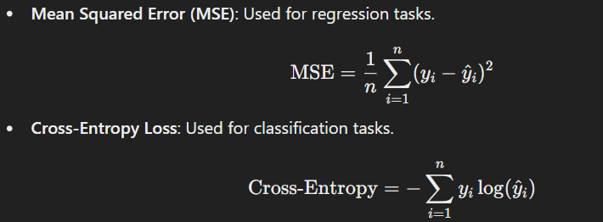

# Artificial Neuron Activation and Output Characteristics

An **artificial neuron** is the fundamental building block of a neural network. It mimics the functioning of a biological neuron by taking weighted inputs, applying an activation function, and producing an output.

# Diagram of an Artificial Neuron

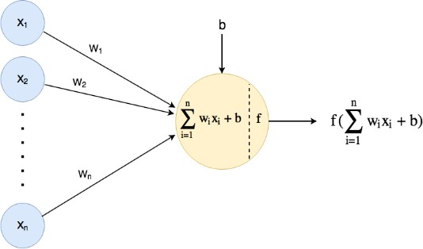

# Explanation of an Artificial Neuron

An artificial neuron operates in three main steps:

# Input and Weighted Sum

Each neuron receives multiple inputs (x1,x2,…,xnx_1, x_2, \dots, x_n) with associated weights

(w1,w2,…,wnw_1, w_2, \dots, w_n) and computes a weighted sum of these inputs along with a bias term (bb):

z=∑i=1nwixi+bz = \sum_{i=1}^{n} w_i x_i + b

This weighted sum zz is the input to the activation function.

# Activation Function

The **activation function** determines whether the neuron should be "activated" or not, introducing non-linearity to the model. Common activation functions are:

|  |  |  |  |  |
| --- | --- | --- | --- | --- |
| **Activation**  **Function** | **Equation** | | **Characteristics** | |
| **Linear** | f(z)=zf(z) = z | | No non-linearity, used for regression. | |
| **Sigmoid** | f(z)=11+e−zf(z) = \frac{1}{1 + e^{-z}} | | Output between 0 and 1, used for binary classification. | |
| **Tanh** | f(z)=ez−e−zez+e−zf(z) = \frac{e^z - e^{- z}}{e^z + e^{-z}} | | Output between -1 and 1, centered  around 0. | |
| **ReLU** | f(z)=max⁡(0,z)f(z) = \max(0, z) | Introduces sparsity, used in deep networks. | |

# Output

The output yy of the neuron is:

y=f(z)y = f(z)

This output is either passed to the next layer of neurons or used as the final output in the case of the output layer.

# Characteristics of Neuron Output Based on Activation Functions

* 1. **Linear Activation:**
     + No non-linearity, output increases linearly with input.
     + Used in the output layer of regression problems.

# Sigmoid Activation:

* + - Smooth curve, output ranges from 0 to 1.
    - Suitable for probability-based outputs (e.g., binary classification).
    - Vanishes gradients for large/small inputs.

# Tanh Activation:

* + - Output ranges from -1 to 1, centered at 0.
    - Better for models where negative values are significant.

# ReLU Activation:

* + - Outputs 0 for negative inputs and linear for positive inputs.
    - Commonly used due to simplicity and efficiency in deep learning.
    - Can suffer from the "dying ReLU" problem (neurons output 0 for all inputs).

**Neural Network Based Pattern Associators**

# **Neural Pattern Associators, and Function in Neural Networks for Pattern Recognition Tasks**

**Neural Pattern Associators** are a type of artificial neural network designed to map input patterns to corresponding output patterns. They are commonly used for pattern recognition, where the goal is to associate certain inputs (e.g., images, signals) with specific outputs (e.g., labels, categories). These networks work by learning the relationships between input-output pairs through a training process. A **Neural Pattern Associator** is a type of artificial neural network that is specifically designed to map one set of patterns (inputs) to another set of patterns (outputs). These are used for tasks where the goal is to recognize a pattern and provide a corresponding output, such as in image recognition, speech recognition, or classification tasks. In this context, **pattern association** refers to the ability of a neural network to recall the correct output (or associated pattern) given an input pattern.

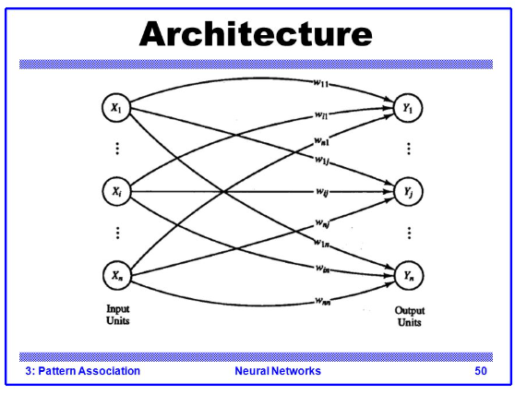

# Key Features of Neural Pattern Associators:

* + **Input Layer:** Represents the features of the input data (e.g., pixel values for images).
  + **Output Layer:** Represents the desired output, such as class labels or reconstructed patterns.
  + **Weights:** Connections between the input and output layers. These weights are adjusted during training to minimize error and improve pattern association.
  + **Learning Process:** Typically employs supervised learning using algorithms like gradient

descent. The network iteratively adjusts its weights based on the error between predicted and actual outputs.

# Functioning in Pattern Recognition Tasks:

1. **Training Phase:**
   * The network is presented with labeled input-output pairs.
   * The weights are updated to minimize the difference between predicted and actual outputs.

# Testing/Inference Phase:

* + New input patterns are presented to the trained network.
  + The network uses learned weights to produce associated outputs.

# Generalization:

* + The network should be able to correctly associate unseen patterns that are similar to those encountered during training.

For example, in image recognition, a neural pattern associator can learn to associate pixel patterns (input) with object categories (output).

# **Character Classification Using a Pattern Associator**

**Character classification** involves identifying and labeling handwritten or printed characters. Neural pattern associators perform this task by learning to map visual patterns (characters) to their respective labels (e.g., 'A', 'B', 'C').

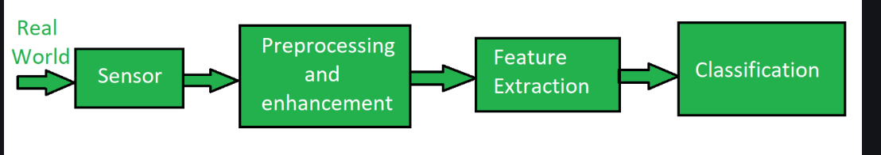

# Process of Character Classification:

1. **Preprocessing the Input:**
   * Characters are typically converted into a standard format, such as grayscale images or binary pixel arrays.
   * Features are extracted from these images, such as pixel intensities or edge patterns.

# Training the Associator:

* + Each character pattern (input) is paired with a corresponding class label (output).
  + The associator is trained using these pairs, adjusting weights to minimize classification errors.

# Association Mechanism:

* + During training, the network learns to map specific patterns to class labels by adjusting its weights.
  + For instance, a pixel array corresponding to the character 'A' is associated with the label 'A'.

# Classification Process:

* + In the inference phase, the network takes a new character image as input.
  + The pattern associator processes the input and assigns a label to it based on the learned associations.
  + For example, given an unseen image of 'B', the network outputs the label 'B' if trained correctly.

# Evaluation:

The performance of the character classification system is evaluated using metrics like:

* **Accuracy:** Percentage of correctly classified characters.
* **Precision and Recall:** To assess how well the system distinguishes between similar characters.

# Advantages:

* Can handle noisy or distorted characters.
* Learns directly from examples without requiring manual feature engineering.

# Example Application:

Optical Character Recognition (OCR) systems use neural pattern associators to convert scanned documents into editable text by classifying character images.

### ****Matrix Approaches (Linear Associative Mappings)****

In pattern recognition, **matrix approaches** to **linear associative mappings** (LAM) are methods used to find a linear relationship between input and output patterns. This approach uses matrices to represent the patterns and their relationships, allowing us to map inputs to outputs through linear transformations.

Linear associative mapping is a concept where an input pattern is mapped to an output pattern by applying a linear transformation, often represented in matrix form. This type of mapping is useful in various tasks, including classification, prediction, and even in certain types of neural network training.

### ****Key Concepts of Matrix Approaches****

* **Linear Transformation**: The transformation between input and output patterns is assumed to be linear, i.e., it can be represented by matrix multiplication.
* **Input-Output Matrix Representation**: Both input and output patterns are represented as vectors or matrices. The transformation between these matrices is achieved through multiplication by a weight matrix.
* **Matrix Equation**: The relationship between the input vector x and the output vector y can be expressed as:
  + - y=XW

Where:

X is the matrix of input vectors (data).

W is the matrix of weights (linear transformation coefficients).

y is the matrix of output vectors (resulting patterns)

The goal is to learn the weight matrix W so that it transforms input patterns to output patterns correctly.

### ****How Matrix Approaches Work****

### 

### 

### ****Applications****:

1. **Classification**: Used for supervised learning to map input features to categories.
2. **Regression**: Mapping inputs to continuous outputs.
3. **Signal Processing**: Tasks like noise reduction and signal transformation.
4. **Data Compression**: Using matrix decomposition techniques like SVD.
5. **Image Recognition**: Mapping features of images to labels.

# Question Reasons to Adopt a Neural Computational Architecture

1. **Ability to Learn and Generalize from Data:** Neural networks excel in learning directly from raw data without the need for extensive feature engineering. By identifying patterns and relationships in the data during the training phase, they can generalize well to unseen data, making them highly adaptable to new and dynamic environments. This learning capability is especially important in tasks like speech recognition, image classification, and natural language processing, where traditional algorithms may struggle.
2. **Handling Non-Linear and Complex Relationships:** Neural networks are designed to capture non-linear and complex interactions between variables that traditional linear models cannot handle. By utilizing non-linear activation functions such as ReLU, Sigmoid, or Tanh, they

transform input data through multiple layers to extract intricate features. This ability to model complex relationships makes them suitable for tasks like predicting weather patterns, financial market trends, or even human behavior.

1. **Versatility Across Domains:** Neural computational architectures are highly versatile and can be applied across diverse fields, including healthcare, finance, robotics, and entertainment. In healthcare, for instance, neural networks are used for early diagnosis of diseases,

analyzing medical images, and predicting patient outcomes. In finance, they are leveraged for fraud detection, risk assessment, and credit scoring. This cross-domain applicability makes them a preferred choice for solving a wide range of problems.

1. **Scalability and Flexibility:** Neural networks are inherently scalable and can be customized to fit specific problem requirements. They can be scaled up by increasing the number of layers (deep learning) or the number of neurons per layer, allowing them to tackle more complex problems. Furthermore, different architectures like Convolutional Neural Networks (CNNs) for image processing, Recurrent Neural Networks (RNNs) for sequential data, and

Transformers for language tasks offer flexibility in their design and application.

1. **Robustness to Noisy Data:** Neural networks are capable of handling noisy, incomplete, or unstructured data better than many traditional algorithms. They can learn to focus on

relevant patterns while ignoring irrelevant or noisy information, making them ideal for applications like speech recognition, where background noise is a common issue, or in financial markets, where data is often noisy and unpredictable.

1. **Support for Parallel and Distributed Processing:** Modern neural networks, particularly deep learning models, can leverage parallel and distributed computing environments, such as

GPUs and cloud computing platforms, to process large datasets efficiently. This parallelism reduces training time significantly and enables the deployment of large-scale models for

tasks like real-time object detection, autonomous driving, and large-scale recommendation systems, making neural computational architectures highly efficient and scalable for

industrial applications.

### ****Characteristics of Neural Computing Applications****

1. **Ability to Handle Non-Linear Problems**
   * Neural networks excel at solving **non-linear and complex relationships** that traditional models struggle with.
   * By using **activation functions** like ReLU, Sigmoid, or Tanh, neural networks introduce non-linearity, enabling them to model real-world data.
2. **Learning from Data**
   * Neural networks **learn patterns** and relationships automatically from data without requiring explicit programming.
   * They adapt their **weights and biases** during the training process to minimize error and improve predictions.
3. **Robustness to Noise and Incomplete Data**
   * Neural computing applications are **resilient to noisy, missing, or irrelevant data**.
   * Through training, they generalize well and can extract meaningful patterns, even in imperfect data.
4. **Parallel Distributed Processing**
   * Neural networks perform computations in a **parallel and distributed manner**.
   * Each neuron in a layer processes its input independently, making neural networks computationally efficient for large-scale data.
5. **High-Dimensional Data Handling**
   * Neural networks can handle **high-dimensional and unstructured data**, such as images, text, or sensor data.
   * Techniques like **convolutional layers** (CNNs) for image data or **embeddings** for textual data enable them to process complex inputs effectively.
6. **Generalization Capability**
   * After sufficient training, neural networks can **generalize** to unseen data, allowing them to make accurate predictions on new inputs.
   * This characteristic is particularly useful for tasks like classification and regression.
7. **Adaptability and Flexibility**
   * Neural networks are highly adaptable and can be applied to a **wide variety of domains**:
     + Image and speech recognition
     + Natural Language Processing (NLP)
     + Predictive analytics
     + Robotics and control systems
8. **Black Box Nature**
   * Neural networks act as **"black boxes"**, meaning their decision-making processes are complex and opaque.
   * While they are highly accurate, interpreting **how and why** decisions are made can be difficult, especially in critical applications like healthcare or finance.
9. **Scalability**
   * Neural networks are **scalable** and can be applied to both small and large datasets.
   * Modern computing techniques (e.g., GPUs and cloud computing) allow neural networks to scale efficiently for **big data** applications.

# CAM (Content Addressable Memory) and Other Neural Memory Structures

Neural networks often require **memory structures** to enhance their ability to learn, store, and retrieve information. These memory mechanisms allow models to handle complex tasks such as sequence prediction, reasoning, and pattern matching.

# Content Addressable Memory (CAM)

**Content Addressable Memory (CAM)**, also known as **associative memory**, is a type of memory that retrieves data based on the content rather than the address.

# Key Characteristics of CAM:

* + **Data is retrieved by matching content:** Unlike traditional memory, where data is accessed by its location, CAM searches for and retrieves data based on input patterns.
  + **Parallel Search:** CAM performs a parallel search across all memory locations, making it faster than traditional memory.
  + **Associative Retrieval:** It is often used to store key-value pairs, and when a key or partial pattern is presented, the corresponding value is retrieved.

# Diagram of CAM Structure

* + **Input Pattern:** The data pattern used to query the memory.
  + **Memory Cells:** Store patterns and their corresponding output.
  + **Matching Unit:** Compares input patterns with stored patterns.
  + **Output:** Returns the data corresponding to the matched pattern.

# Applications of CAM:

1. **Cache Memories:** CAM is used in associative caches to match tags with stored memory locations.
2. **Neural Networks:** Associative memories like Hopfield networks or Kohonen self-organizing maps are used for pattern recognition.
3. **Routers:** Used in network routers for fast lookups of IP addresses or MAC tables.

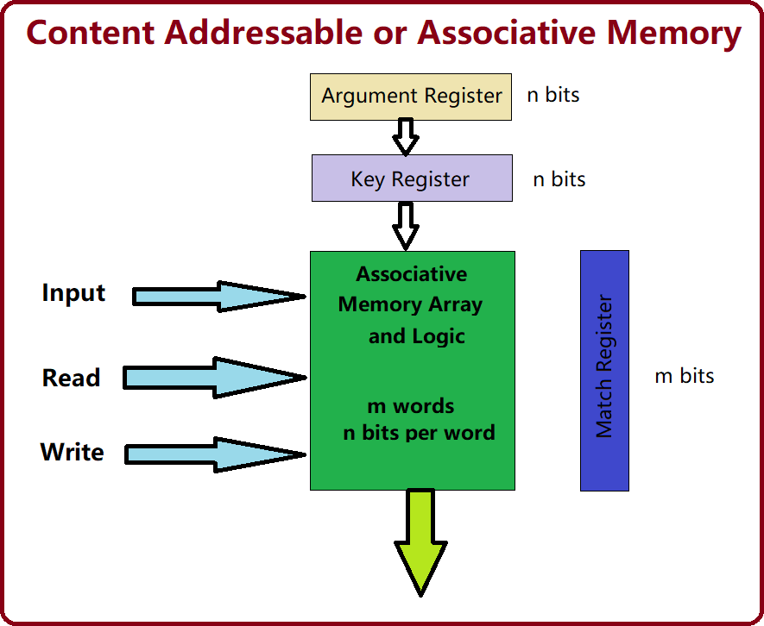

# Neural Memory Structures

Several other memory structures are used in neural networks, particularly in models that require long-term dependencies, pattern storage, or associative learning.

# Hopfield Networks

* + A recurrent neural network with binary threshold neurons that act as associative memory systems.
  + **Energy-Based Model:** The network converges to a stable state by minimizing an energy function.
  + **Use Case:** Pattern recognition and noise removal.

# Kohonen Networks (Self-Organizing Maps)

* + A type of unsupervised learning neural network that organizes data into a lower-dimensional map.
  + **Feature Mapping:** The network clusters and maps similar input patterns to nearby neurons.
  + **Use Case:** Data visualization, clustering, and pattern matching.

# Long Short-Term Memory (LSTM) Networks

* + A type of recurrent neural network (RNN) designed to handle **long-term dependencies** by using memory cells.
  + **Gates:** LSTMs use input, forget, and output gates to control information flow.
  + **Use Case:** Sequence prediction, language modeling, and time-series forecasting.

# Memory-Augmented Neural Networks (MANNs)

* + Neural networks augmented with an external memory matrix.
  + **Read and Write Operations:** The network can read from and write to external memory, similar to how a computer operates.
  + **Example:** Neural Turing Machines and Differentiable Neural Computers.
  + **Use Case:** Complex reasoning tasks, question answering, and algorithm learning.

# Transformer Networks (Attention Mechanism)

* + **Attention Mechanism:** A memory structure that allows the network to focus on relevant parts of the input data.
  + **Self-Attention:** Computes a weighted sum of all input elements, focusing on important ones.
  + **Use Case:** Language translation, text generation, and image captioning.

# Comparison of Neural Memory Structures

|  |  |  |  |
| --- | --- | --- | --- |
| **Memory Structure** | **Type** | **Primary Use** | **Key Feature** |
| **Content Addressable Memory** | Associative | Fast lookups, caching | Parallel search and retrieval |
| **Hopfield Networks** | Associative | Pattern recognition | Converges to stable patterns |
| **Kohonen Networks** | Associative | Clustering, feature mapping | Unsupervised learning |
| **LSTM Networks** | Sequential | Time-series prediction | Long-term memory control |
| **Memory-Augmented Neural Networks** | External Memory | Complex reasoning | External memory matrix |
| **Transformer Networks** | Attention | NLP tasks, translation | Focused attention mechanism |

### ****Neural Networks as a Black Box Approach****

1. **Definition of Neural Networks as a Black Box**:
   * Neural networks are often called a "black box" because their internal processes are difficult to understand or interpret.
   * While they automatically learn from data, their decision-making processes remain opaque.
2. **Structure of Neural Networks**:
   * Composed of **multiple layers** of interconnected **neurons**.
     + **Input Layer**: Accepts input data.
     + **Hidden Layers**: Perform mathematical operations to transform inputs.
     + **Output Layer**: Provides predictions.
   * Neurons apply weights, biases, and activation functions to process data.
3. **Training Phase**:
   * The network learns patterns and adjusts internal parameters (**weights** and **biases**) to minimize prediction errors.
   * Techniques used for training include:
     + **Gradient Descent**: Optimizes weights to reduce loss (error).
     + **Backpropagation**: Adjusts weights by propagating errors backward from output to input.
4. **Reason for Black Box Nature**:
   * Neural networks involve **complex operations** and a **large number of parameters**.
   * It is difficult to trace how specific inputs result in specific outputs due to the network's non-linear transformations.
5. **Strengths of Neural Networks**:
   * **Excels at Complex Problems**: Effective where traditional algorithms fail.
   * **Tasks**:
     + **Image Recognition**: Detects objects and patterns in images.
     + **Natural Language Processing (NLP)**: Processes and understands human language.
     + **Predictive Analytics**: Predicts future trends or outcomes.
   * **Ability**: Models non-linear, high-dimensional relationships and uncovers intricate patterns invisible to simpler models.
6. **Challenges with Black Box Nature**:
   * Lack of transparency raises concerns in **critical domains** where interpretability is crucial:
     + **Healthcare**: Stakeholders need to understand why a disease is predicted.
     + **Finance**: Ensures decisions are reliable, unbiased, and accountable.
     + **Autonomous Systems**: Safety and trust depend on understanding AI behavior.
7. **Efforts to Improve Interpretability**:
   * Researchers are developing **Explainable AI (XAI)** techniques to address the black box issue.
   * **XAI Techniques**:
     + Provide insights into **how data is processed**.
     + Identify **important features** influencing predictions.
     + Explain relationships between input and output.
8. **Ongoing Challenge**:
   * Balancing high performance with interpretability remains a key area of research in AI.
   * Perfect transparency without compromising accuracy is yet to be achieved.
9. **Conclusion**:
   * Neural networks offer significant predictive power and flexibility.
   * However, their black box nature continues to be a challenge, especially in domains requiring trust, accountability, and transparency.

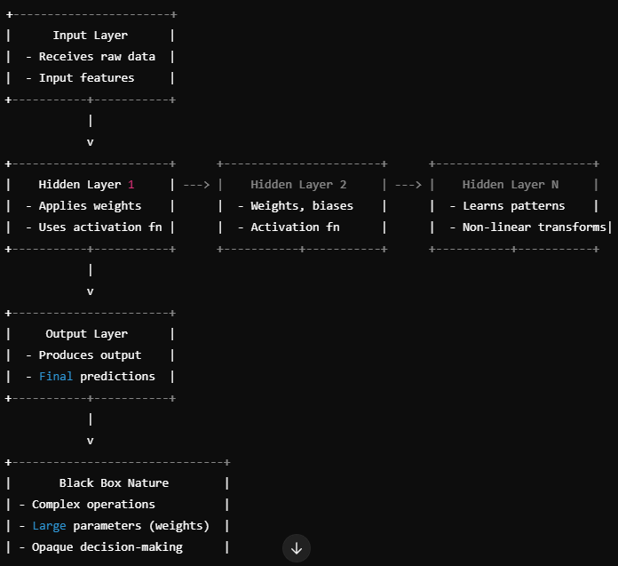

**UNIT 6**

# Structure of a Multiple Layer Feedforward Network

A **Multiple Layer Feedforward Network (MLFN)** is a type of artificial neural network (ANN) where the information flows in one direction, from the input layer to the output layer, passing through one or more hidden layers. This network is also known as a **Multilayer Perceptron (MLP)**.

# Diagram of a Multiple Layer Feedforward Network

* **Input Layer** with 3 neurons
* **Hidden Layer** with 4 neurons
* **Output Layer** with 2 neurons

The connections between layers will illustrate the flow of information from the input to the output layer.

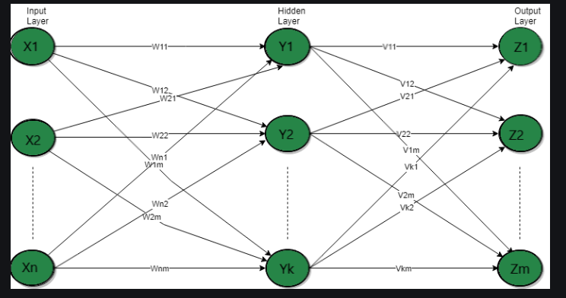

# Explanation of a Multiple Layer Feedforward Network

A Multiple Layer Feedforward Network typically consists of the following components:

# Input Layer:

* + The first layer of the network.
  + Receives the raw input data.
  + Each neuron in the input layer represents a feature of the input data.
  + Example: If predicting laptop prices, input features could be RAM size, processor speed, and storage capacity.

# Hidden Layer(s):

* + One or more intermediate layers between the input and output layers.
  + Each neuron in the hidden layer applies a weighted sum of its inputs followed by an activation function (e.g., ReLU, Sigmoid, or Tanh).
  + Purpose:
    - Capture complex patterns in the data.
    - Perform transformations on the input data to learn non-linear relationships.
  + More hidden layers increase the network's capacity to model complex relationships, but also increase the risk of overfitting.

# Output Layer:

* + The final layer of the network.
  + Produces the output of the network.
  + Each neuron in this layer corresponds to a possible output.
  + Example: In a classification task, each output neuron might represent a different class.

# Working of the Network:

1. **Forward Propagation:**
   * Data flows from the input layer through the hidden layers to the output layer.
   * Each neuron computes a weighted sum of its inputs and applies an activation function.

# Weight Updates:

* + After forward propagation, weights are updated using **backpropagation** to minimize the error between predicted and actual outputs.

# Activation Functions:

* + Non-linear activation functions (e.g., ReLU, Sigmoid) are used in hidden layers to allow the network to learn complex patterns.

# Advantages:

* Can model complex and non-linear relationships.
* Suitable for tasks like classification, regression, and feature extraction.

# Disadvantages:

* Requires large datasets and computational power.
* Risk of overfitting if not properly regularized.
* Training can be time-consuming and requires careful tuning of hyper parameters.

### Training a Feedforward Network using the Generalized Delta Rule (Backpropagation)

The **Generalized Delta Rule**, also known as the **Backpropagation Algorithm**, is used to train feedforward neural networks by minimizing the error between the predicted and actual outputs. This method employs **gradient descent** to adjust the weights of the network.

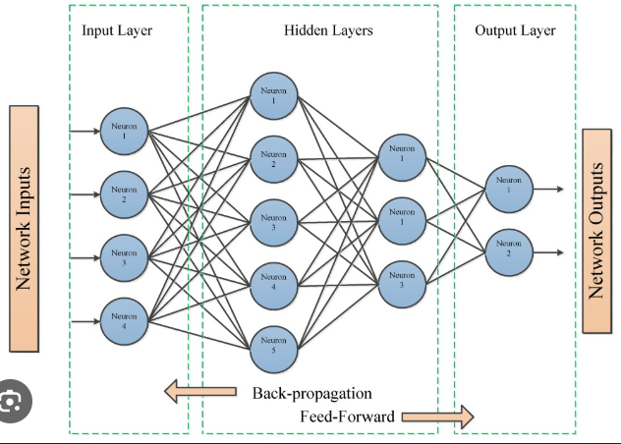

### ****Explanation: Training a Feedforward Neural Network Using the Generalized Delta Rule****

The training process involves two main phases: **Forward Propagation** and **Backward Propagation of errors** using the Generalized Delta Rule. Here's a step-by-step explanation:

### 

### 

### ****Extension of the Dimensionality Reduction (DR) for Units in the Hidden Layers****

In neural networks, **Dimensionality Reduction (DR)** techniques can be applied to the **hidden layers** to optimize network performance, improve efficiency, and enhance generalization. DR aims to reduce the number of neurons (units) in the hidden layers without significantly affecting the model's accuracy. This is particularly useful for managing large models or datasets with high-dimensional features.

### ****Techniques for Dimensionality Reduction in Hidden Layers****

1. **Principal Component Analysis (PCA)**
   * PCA is a statistical technique that transforms input features into a smaller set of **principal components** that capture most of the variance.
   * Applied to hidden layers, PCA can reduce the number of neurons by projecting the data into a **lower-dimensional space**.
   * This helps to eliminate redundant and less significant features.

**Key Benefits**:

* + Reduces computational complexity.
  + Improves training time.
  + Minimizes overfitting.

1. **Singular Value Decomposition (SVD)**
   * SVD decomposes a matrix into three components: U, Σ (singular values), and V.
   * For hidden layers, SVD can approximate the weight matrices, reducing their rank and dimensionality while preserving important information.

**Key Benefits**:

* + Reduces the number of connections and parameters in the network.
  + Accelerates forward and backward propagation.

1. **Auto encoders for Compression**
   * An **autoencoder** is a type of neural network that learns an efficient, lower-dimensional representation of the data.
   * The bottleneck layer (latent space) compresses high-dimensional inputs into fewer neurons.
   * In hidden layers, using an autoencoder can pre-train the network or optimize the units by learning compressed features.

**Key Benefits**:

* + Reduces unnecessary neurons.
  + Learns compact, informative features.
  + Useful for pre-training deep networks.

1. **Regularization Techniques**
   * Techniques like **Dropout** and **L1/L2 Regularization** can implicitly reduce the dimensionality of hidden layers:
     + **Dropout** randomly deactivates neurons, leading the model to focus only on critical units.
     + **L1 Regularization** encourages sparsity in the hidden layer by penalizing non-zero weights, effectively reducing the number of active neurons.

**Key Benefits**:

* + Reduces overfitting.
  + Forces the model to rely on a smaller set of important neurons.
  + Improves generalization.

1. **Pruning of Neurons**
   * Pruning involves **removing neurons or connections** in hidden layers that contribute minimally to the overall output.
   * Methods include:
     + **Magnitude-Based Pruning**: Removes weights with small magnitudes.
     + **Iterative Pruning**: Gradually removes insignificant neurons during training.

**Key Benefits**:

* + Reduces model size.
  + Speeds up inference time.
  + Optimizes resource usage.

1. **Low-Rank Factorization**
   * Hidden layer weight matrices can be factorized into **low-rank approximations** to reduce dimensionality.
   * Instead of a full weight matrix, the product of two smaller matrices can approximate the original weights.

**Key Benefits**:

* + Reduces the number of parameters.
  + Maintains accuracy with fewer computations.

### ****Impact of DR on Hidden Layers****

* **Faster Training and Inference**: Fewer neurons reduce computation time for both forward and backward passes.
* **Reduced Overfitting**: Simplifies the network to focus on key patterns, improving generalization.
* **Memory Efficiency**: Lower dimensionality reduces the storage needed for weights and activations.
* **Improved Interpretability**: Fewer units make the network easier to analyze and understand.

### ****Challenges of DR in Hidden Layers****

* Risk of **Information Loss** if too many neurons are removed.
* Over-reduction may **hurt accuracy** and learning capacity.
* Requires careful selection of techniques and tuning to maintain performance.

# Self-Organizing Networks: A Primer

Self-Organizing Networks (SONs), often referred to as Self-Organizing Maps (SOMs), are a type of artificial neural network that learns to classify input data without the need for labeled training examples. This unsupervised learning technique is particularly effective in pattern recognition tasks, as it can automatically discover underlying structures and relationships within data.

# Primary Functions of Self-Organizing Networks:

1. **Dimensionality Reduction:** SOMs can reduce the dimensionality of high-dimensional data while preserving its topological structure. This is achieved by mapping input data onto a lower-dimensional grid of neurons, where similar inputs are mapped to neighboring neurons.
2. **Clustering and Classification:** By organizing neurons into clusters, SOMs can identify natural groupings within data. This clustering capability is valuable for tasks like customer segmentation, image analysis, and anomaly detection.
3. **Feature Extraction:** SOMs can extract relevant features from input data. This is particularly useful in applications where the underlying features are not explicitly known or defined.
4. **Visualization:** SOMs provide a visual representation of the data distribution, allowing for easy interpretation and analysis. This visualization can help identify patterns, trends, and outliers.

# Applications of Self-Organizing Networks in Pattern Recognition:

1. **Image and Signal Processing:**
   * Image segmentation: Dividing images into meaningful regions based on texture, color, or intensity.
   * Feature extraction: Identifying relevant features from images, such as edges, corners, and textures.
   * Noise reduction: Filtering out noise from images or signals.

# Data Mining and Knowledge Discovery:

* + Clustering: Grouping similar data points together to identify patterns and trends.
  + Anomaly detection: Identifying unusual data points that deviate from normal patterns.
  + Association rule mining: Discovering relationships between different variables in a dataset.

# Bioinformatics:

* + Protein structure analysis: Identifying protein families and functional sites.
  + Gene expression analysis: Clustering genes with similar expression patterns.

# Financial Analysis:

* + Customer segmentation: Grouping customers based on their behavior and preferences.
  + Stock market analysis: Identifying trends and patterns in stock prices.

# Robotics:

* + Sensor data analysis: Interpreting sensor data to make decisions about robot actions.
  + Learning and adaptation: Enabling robots to learn from their environment and adapt to new situations.

# How Self-Organizing Networks Work:

1. **Initialization:** A grid of neurons is created, and their weights are initialized randomly.
2. **Competitive Learning:** An input vector is presented to the network, and each neuron calculates its distance to the input. The neuron with the smallest distance is the "winner."
3. **Weight Update:** The weights of the winning neuron and its neighbors are updated to be more similar to the input vector.
4. **Iteration:** This process is repeated for multiple iterations with different input vectors, gradually organizing the neurons into clusters that represent different patterns in the data.

By leveraging their ability to learn from unlabeled data and discover hidden patterns, self-organizing networks have become a powerful tool in a wide range of pattern recognition applications.

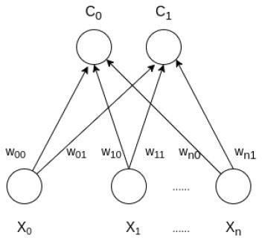

### Advantages of SOM:

* **Topology Preservation:** SOM maintains the topological relationships between data points, making it effective for clustering and visualization.
* **Unsupervised Learning:** It works well with unlabeled data.
* **Nonlinear Dimensionality Reduction:** SOM can reduce the complexity of data without losing essential relationships between data points.

### Limitations of SOM:

* **Sensitive to Initialization:** The outcome of SOM can depend on the initial weight values.
* **Requires Preprocessing:** Data needs to be normalized or standardized to ensure efficient learning.
* **Computational Complexity:** SOM can be computationally intensive, especially for large datasets with high dimensionality.

**Adaptive Resonance Theory (ART)**

**Adaptive Resonance Theory (ART)** is a class of neural network models designed to solve the **stability-plasticity dilemma**, which refers to the challenge of learning new patterns without forgetting previously learned patterns. ART networks are particularly well-suited for **unsupervised learning** tasks such as **pattern recognition**, **clustering**, and **incremental learning**.

### Key Features of ART:

1. **Stability and Plasticity:**
   * **Stability:** Once a pattern is learned, the network should not forget it when learning new patterns.
   * **Plasticity:** The network should be able to learn new patterns without needing to retrain from scratch.
2. **Resonance:**
   * The concept of **resonance** refers to the network's ability to "match" or "resonate" an input pattern with an existing category. If the input pattern is sufficiently similar to an existing category, it is classified under that category. Otherwise, a new category is created.
3. **Category Formation:**
   * ART networks dynamically create new categories as needed. When a new input doesn't match any existing category, the network forms a new category for it.
4. **Vigilance Mechanism:**
   * The **vigilance parameter** controls how strictly an input must match an existing category. If the similarity between an input and an existing category is above the vigilance threshold, it is classified into that category. If not, a new category is formed.

### Architecture of ART:

### 

• **Input Layer:** Receives the incoming data or patterns that need to be categorized.

• **Comparison Layer:** Compares the input pattern to stored patterns and triggers a match if the input is sufficiently close to a category.

• **Category Layer:** Represents the category or cluster of the input data. If the input matches an existing category, the category is updated; otherwise, a new category is created.

• **Vigilance Mechanism:** Ensures that a new input pattern only joins an existing category if it meets a certain similarity threshold. If not, a new category is formed.

### • **Feedback Loops:** Adjust the weights of the network to reinforce correct categorization and adapt as new patterns are learned. This is part of the network's learning mechanism.

### Types of ART:

1. **ART1:** For binary pattern recognition.
2. **ART2:** For continuous-valued input patterns.
3. **ART3:** An extension that handles both discrete and continuous inputs, useful for time-series or sequence recognition tasks.
4. **Fuzzy ART:** For handling fuzzy sets, useful for imprecise data.

### Applications:

* **Pattern Recognition:** ART networks are often used in situations where patterns need to be identified in noisy or unstructured data.
* **Clustering:** ART can perform clustering of input data into categories, making it useful for **unsupervised learning**.
* **Incremental Learning:** ART is ideal for environments where data is continually being introduced, and the system needs to learn continuously without forgetting prior knowledge.
* **Anomaly Detection:** ART networks can identify outliers in data, making them useful for detecting novel patterns or abnormalities.

# Summary of the Backpropagation Learning Procedure

Backpropagation (short for **"backward propagation of errors"**) is a supervised learning algorithm widely used for training artificial neural networks. It calculates the gradient of the loss function with respect to each weight by the chain rule, propagating the error backward through the network.

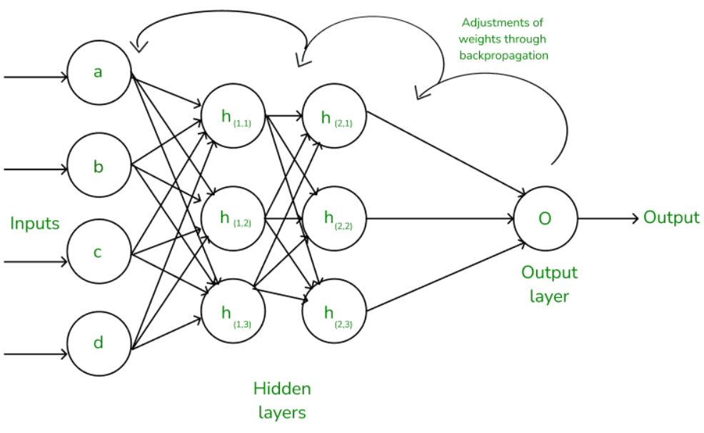

# Explanation of Backpropagation Learning Procedure

The backpropagation process consists of two main phases:

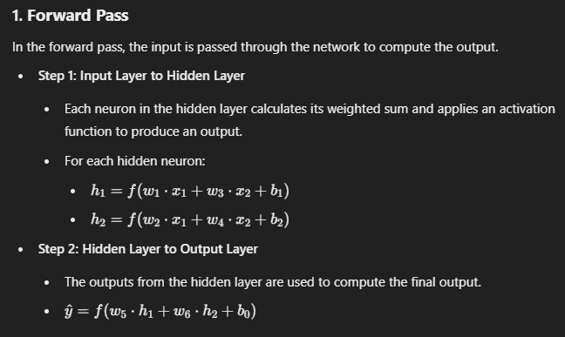

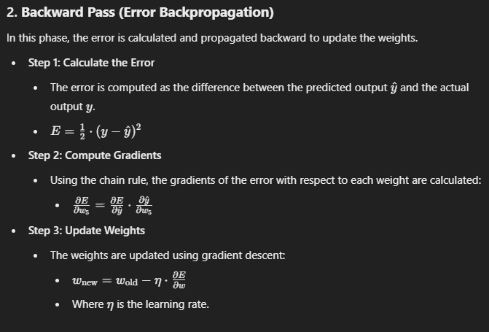

# 3. Key Steps in Backpropagation:

1. **Forward pass:** Compute output by passing inputs through the network.
2. **Error computation:** Calculate the difference between predicted and actual output.
3. **Backward pass:** Propagate the error backward and compute gradients.
4. **Weight update:** Adjust the weights to minimize the error.

# Advantages:

* + Efficient for large networks.
  + Applicable to a variety of network architectures.

# Disadvantages:

* + Can get stuck in local minima.
  + Requires differentiable activation functions.